**Online Live Football Information Website Construction Project**

**1.Introduction:**

Welcome to the Soccer League Website Construction Project - where we aim to provide an exciting platform and comprehensive information about football. This product will assist everyone in effortlessly keeping track of schedules, results, and the latest news from top football tournaments.

**2. Acknowledgments:**

We sincerely express our gratitude to Aptech Global and Aptech Vietnam for organizing the TECHWIZ 4 competition (TECHWIZ - 4th Edition). This project was completed through the relentless efforts of each team member within just 72 hours. Additionally, the support from our guiding instructors has also played a significant role in achieving this accomplishment.

The Soccer League project is not just a mere information-providing website; it also showcases the unity, creativity, and passion of sports enthusiasts, particularly in football. We take pride in this product and would greatly appreciate any contributions for further enhancement from the Techwiz 4th competition judges. This serves as a strong encouragement for us to continue building and developing this project in the future.

Once again, heartfelt thanks to everyone for your invaluable contributions.

**3. Reason for choosing the topic Soccer League:**

We decided to choose the topic Soccer League because of our love and passion for this king sport. Football is not only a game, but also a way of life. We want to create a platform that connects the football-loving community, making it easy for them to access and share important information.

**4. Idea Design and Concept:**

The website will be designed with the main color of red, symbolizing the passion and dynamism of football. The interface will be minimalist, easy to use and user-friendly. High quality images of players and matches will enhance the aesthetics and appeal of the site.

We believe this project will provide an exciting experience for both football fans and technology enthusiasts. Join us towards the goal of building a perfect platform for the football-loving community.

**5.Technologies Used by the Team:**

We utilized fundamental technologies such as HTML5, CSS3 (SCSS), and JavaScript (jQuery) to construct a single-page web by loading data from JSON files and populating the interface. We employed techniques similar to React.js, involving the mounting and unmounting of elements, all written in JavaScript. For styling and responsiveness, we embraced pure CSS3 without employing Bootstrap. Through this competition, we aimed to seize more opportunities for practice and deeper understanding of the core concepts underlying these technologies.

1. **Introducing the whole site:**

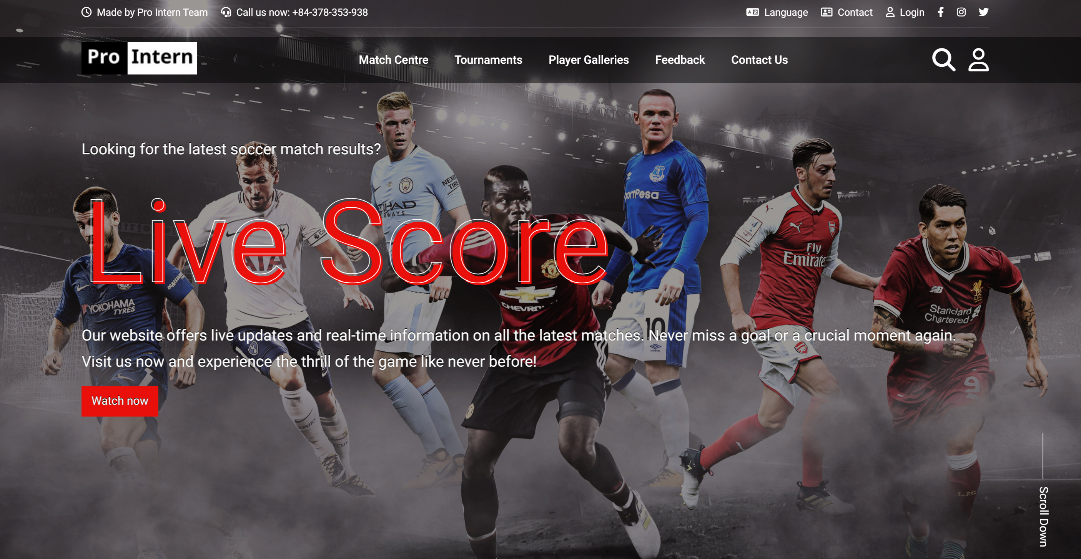

**Homepage Layout**

* The homepage is arranged with a top navigation bar that is divided into two sections: the top navbar and the main navbar.
* The top navbar displays brief information along with contact phone numbers, followed by language options, contact, log in, and social media links.
* Moving on to the main navbar, the main navbar can become sticky as users scroll. It hides when scrolling down and reappears when scrolling up
  + First is the Logo section, which can be clicked to return to the homepage. .
  + it includes the "Match Centre" section with links to match result and upcoming match schedules.
  + The "Tournament" section links to a detailed page listing all tournaments, while the "Player Galleries" section provides information and images of players.
  + Finally, there are "Feedback" and "About Us" links directing users to feedback and information pages.
  + Lastly, there's the search and login section.

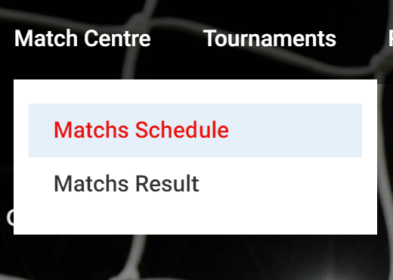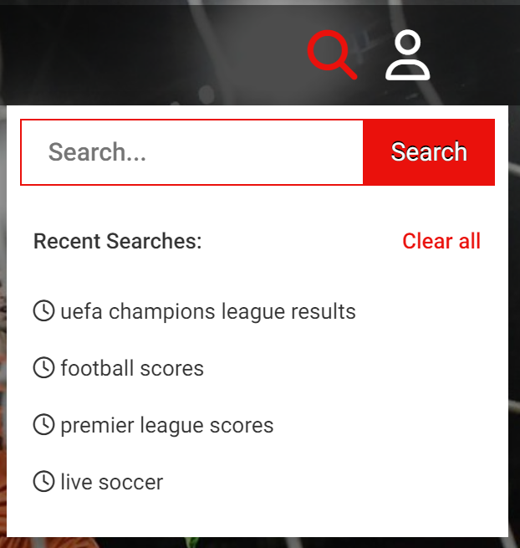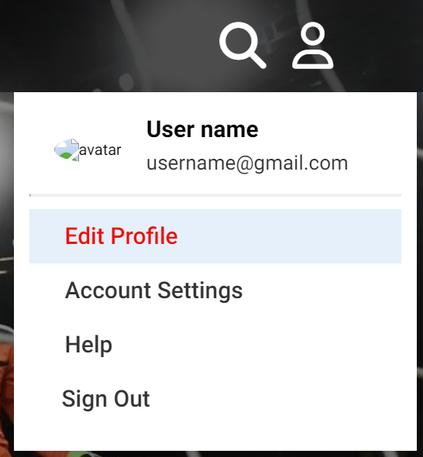

* The slider section comprises 2 background images and 2 concise content blocks that describe the website's functionalities.

**Content Section:**

As you scroll, there will be a gradual appearance of the content on the page. When leaving the top of the page, the scroll to top button will appear

First comes the match results and schedules section.

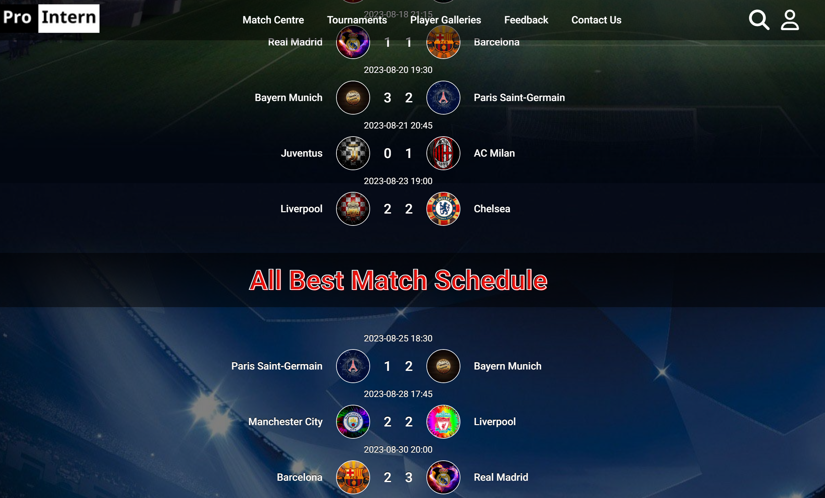

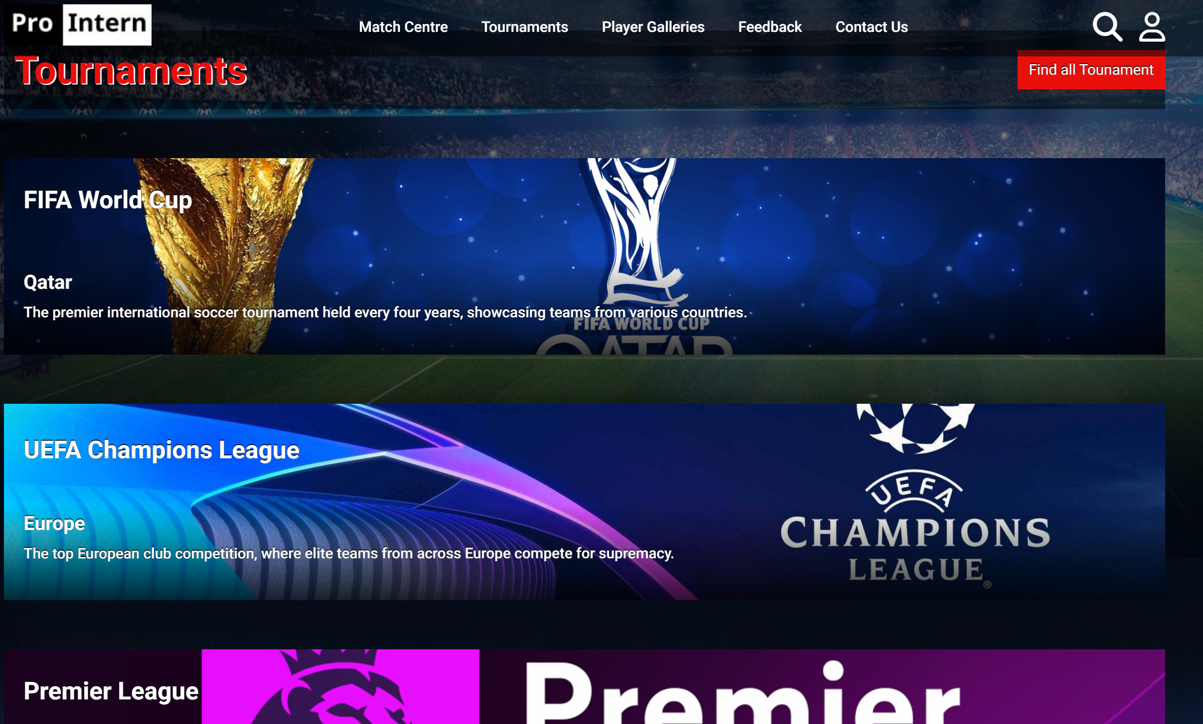Next is the tournament section, where the button will link to the detailed page of all tournaments.

Following that is the section featuring the top 10 teams with the highest scores.

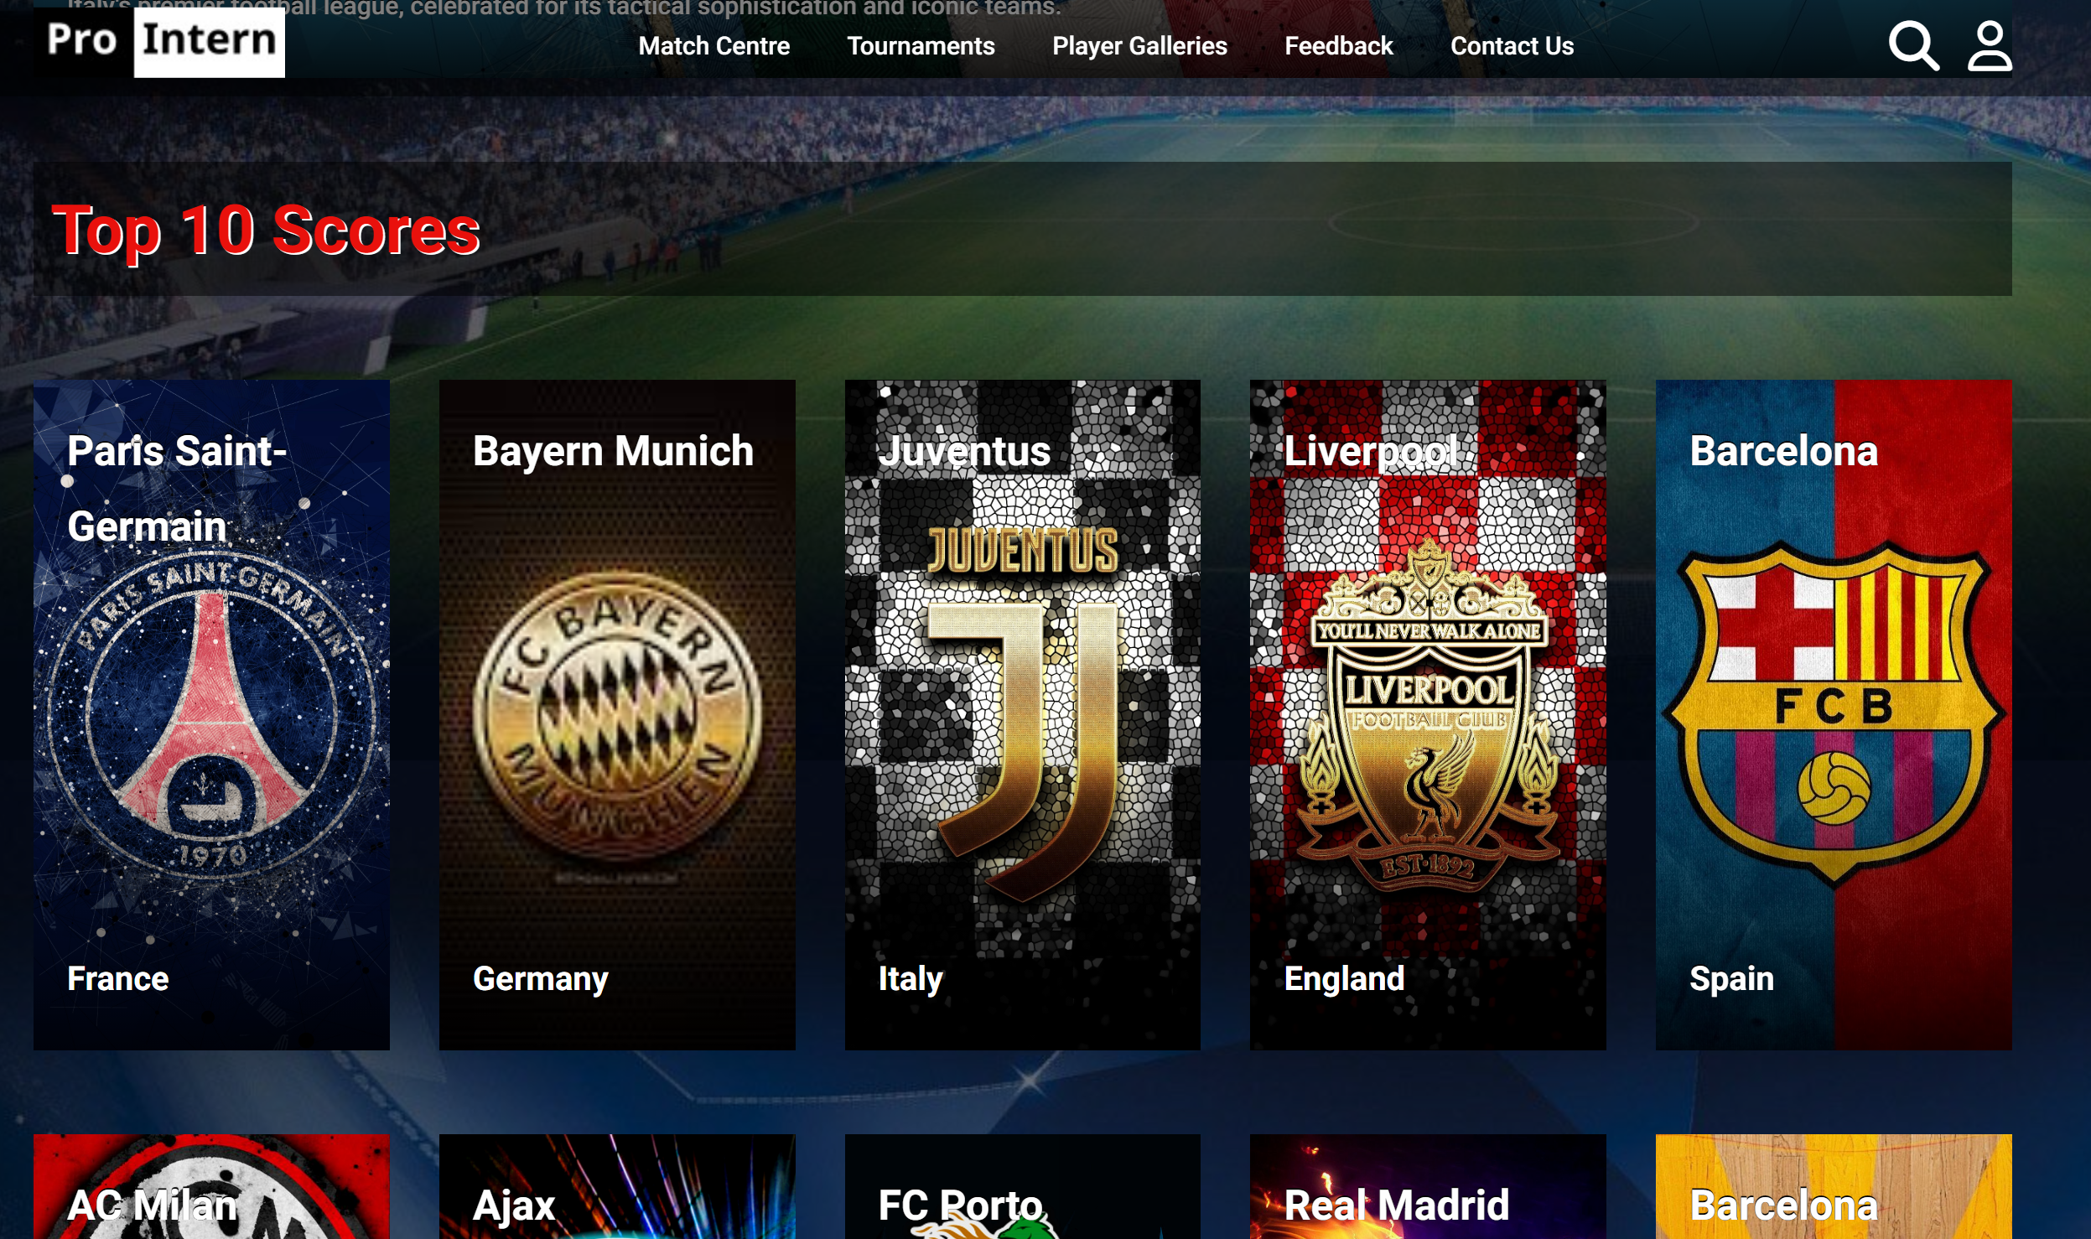

Lastly, there's the top 5 players section with a button that links to detailed player profiles.

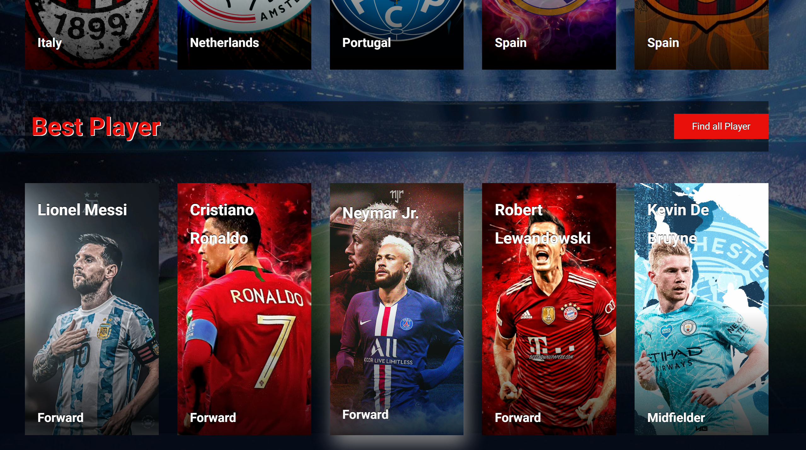

**Detail Pages:**

Player Detail Page: This page lists all players.

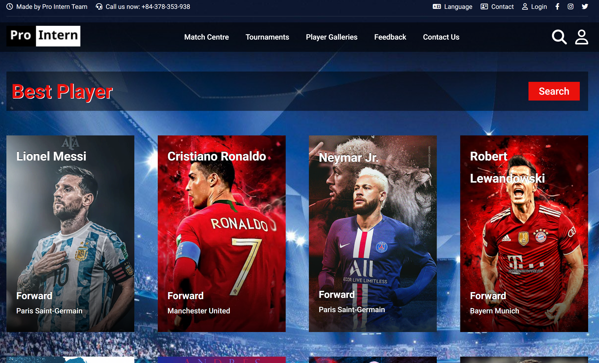

The search section allows users to input information into each search field to search by categories such as name, country, position, and club. Each card's appearance is animated as the user scrolls to its position.

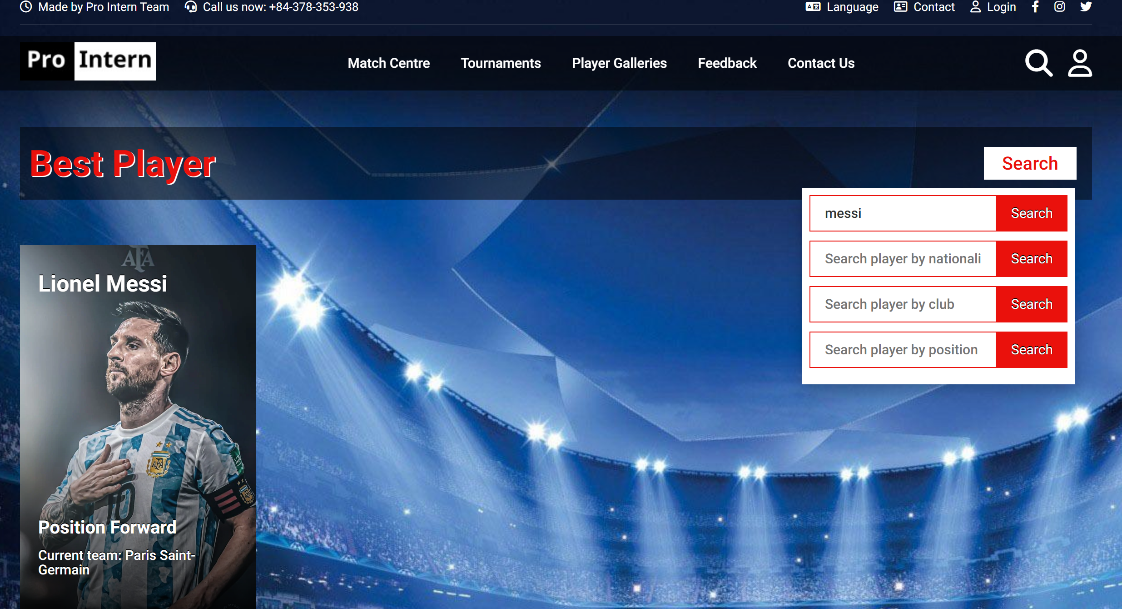

Tournaments Detail Page: This page lists all tournaments.

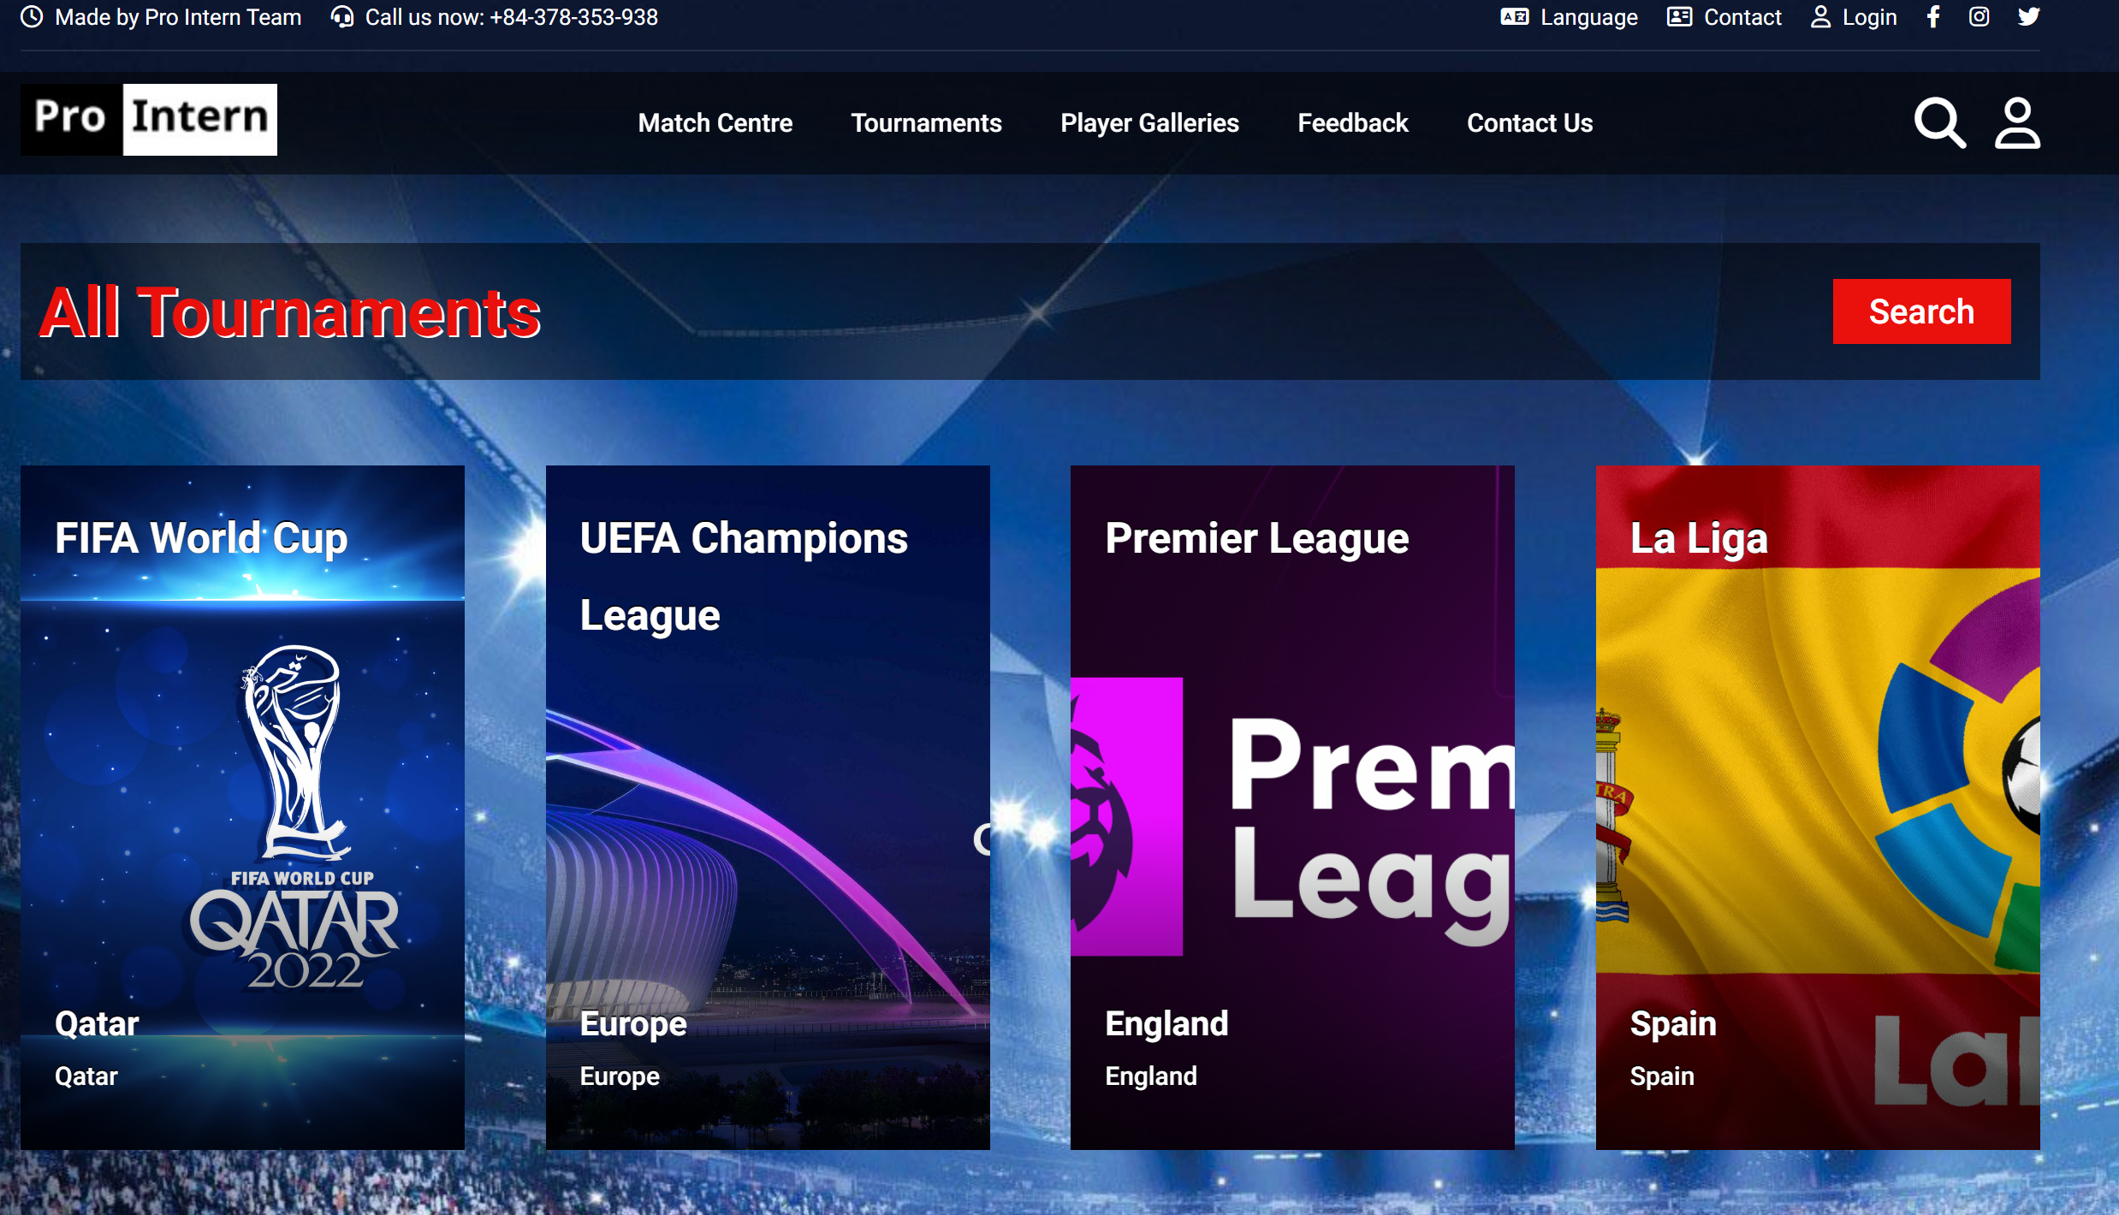

The search section allows users to input information into each search field to search by categories. Similar to the player detail page, each card's appearance is animated as the user scrolls to its position.

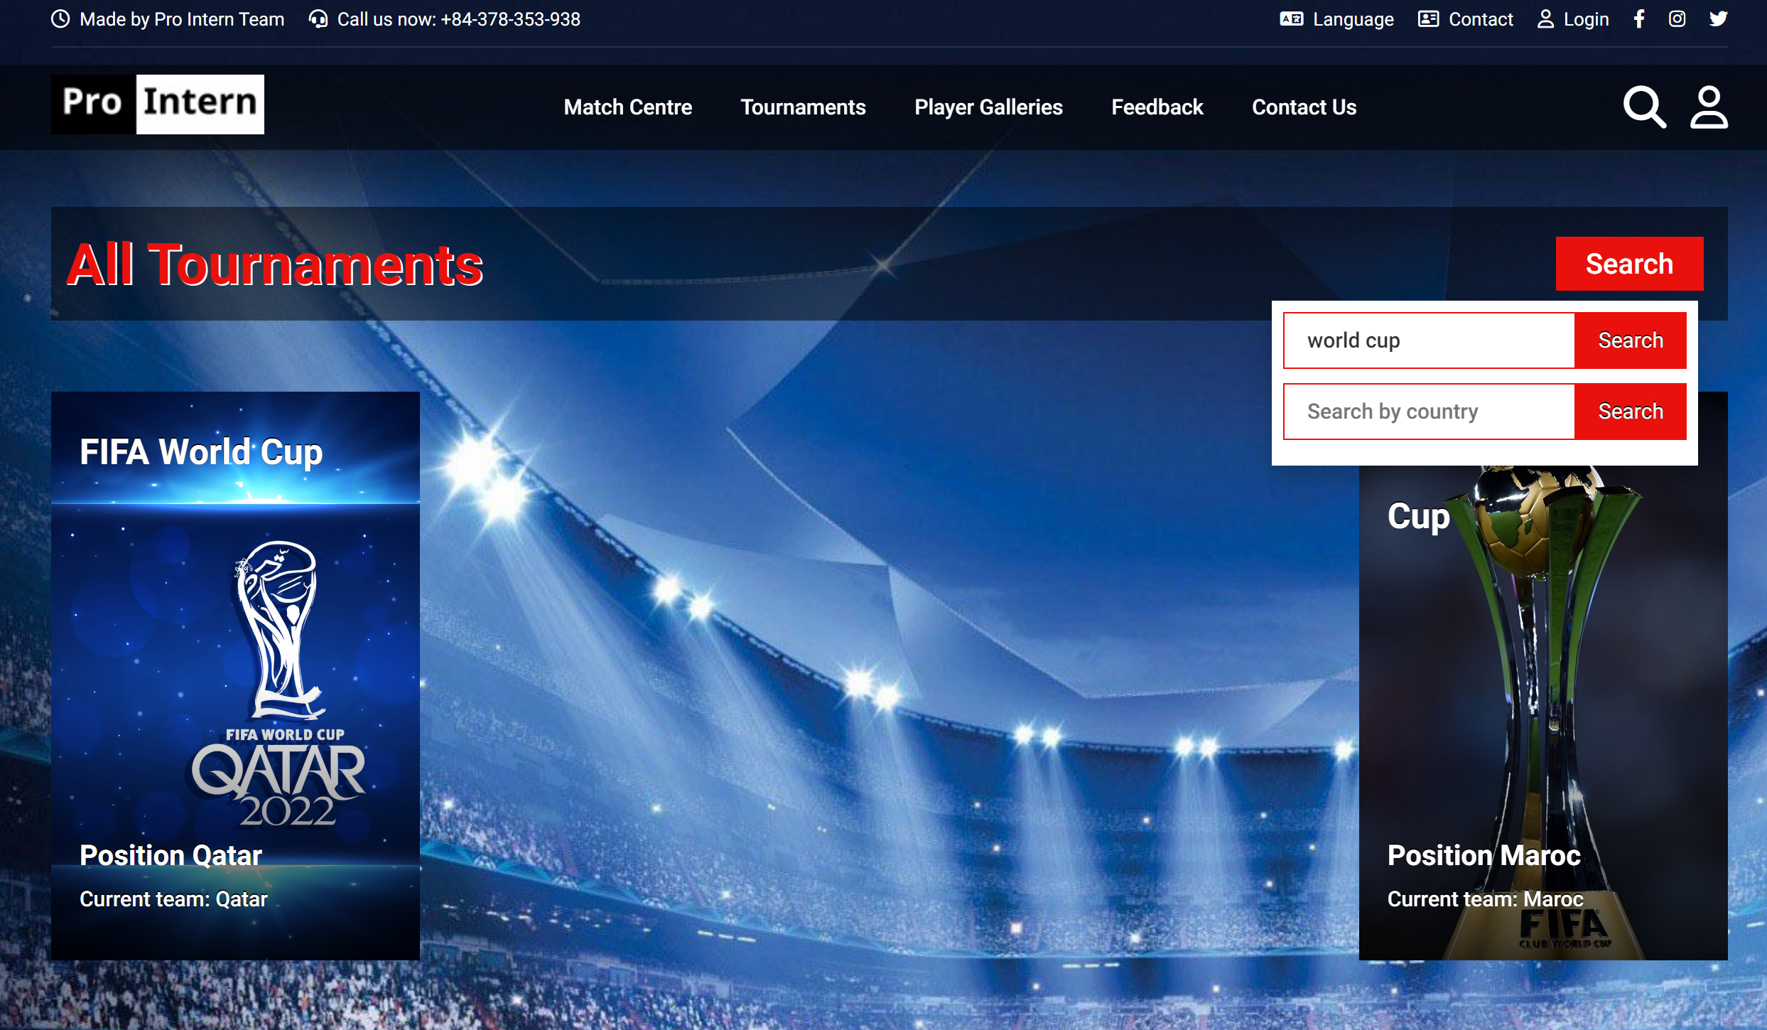

Feedback Page: This page includes input fields and text areas for users to enter and submit feedback.

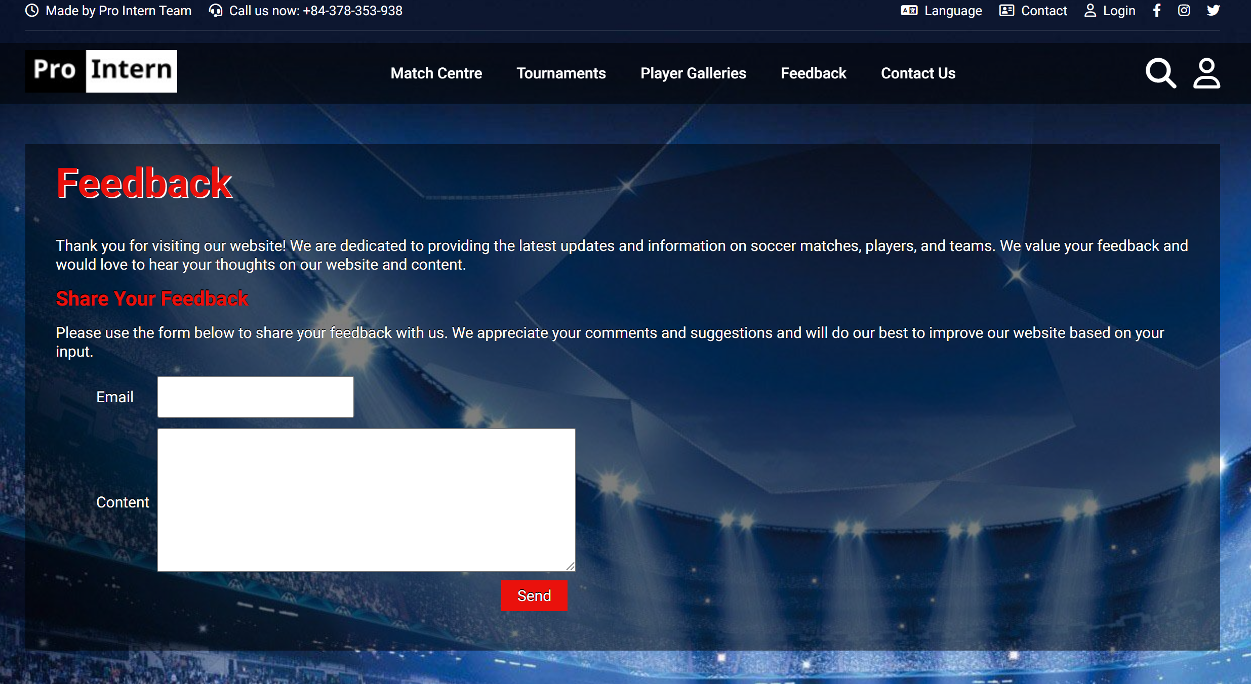

Contact Us Page: This page contains information about the developers.

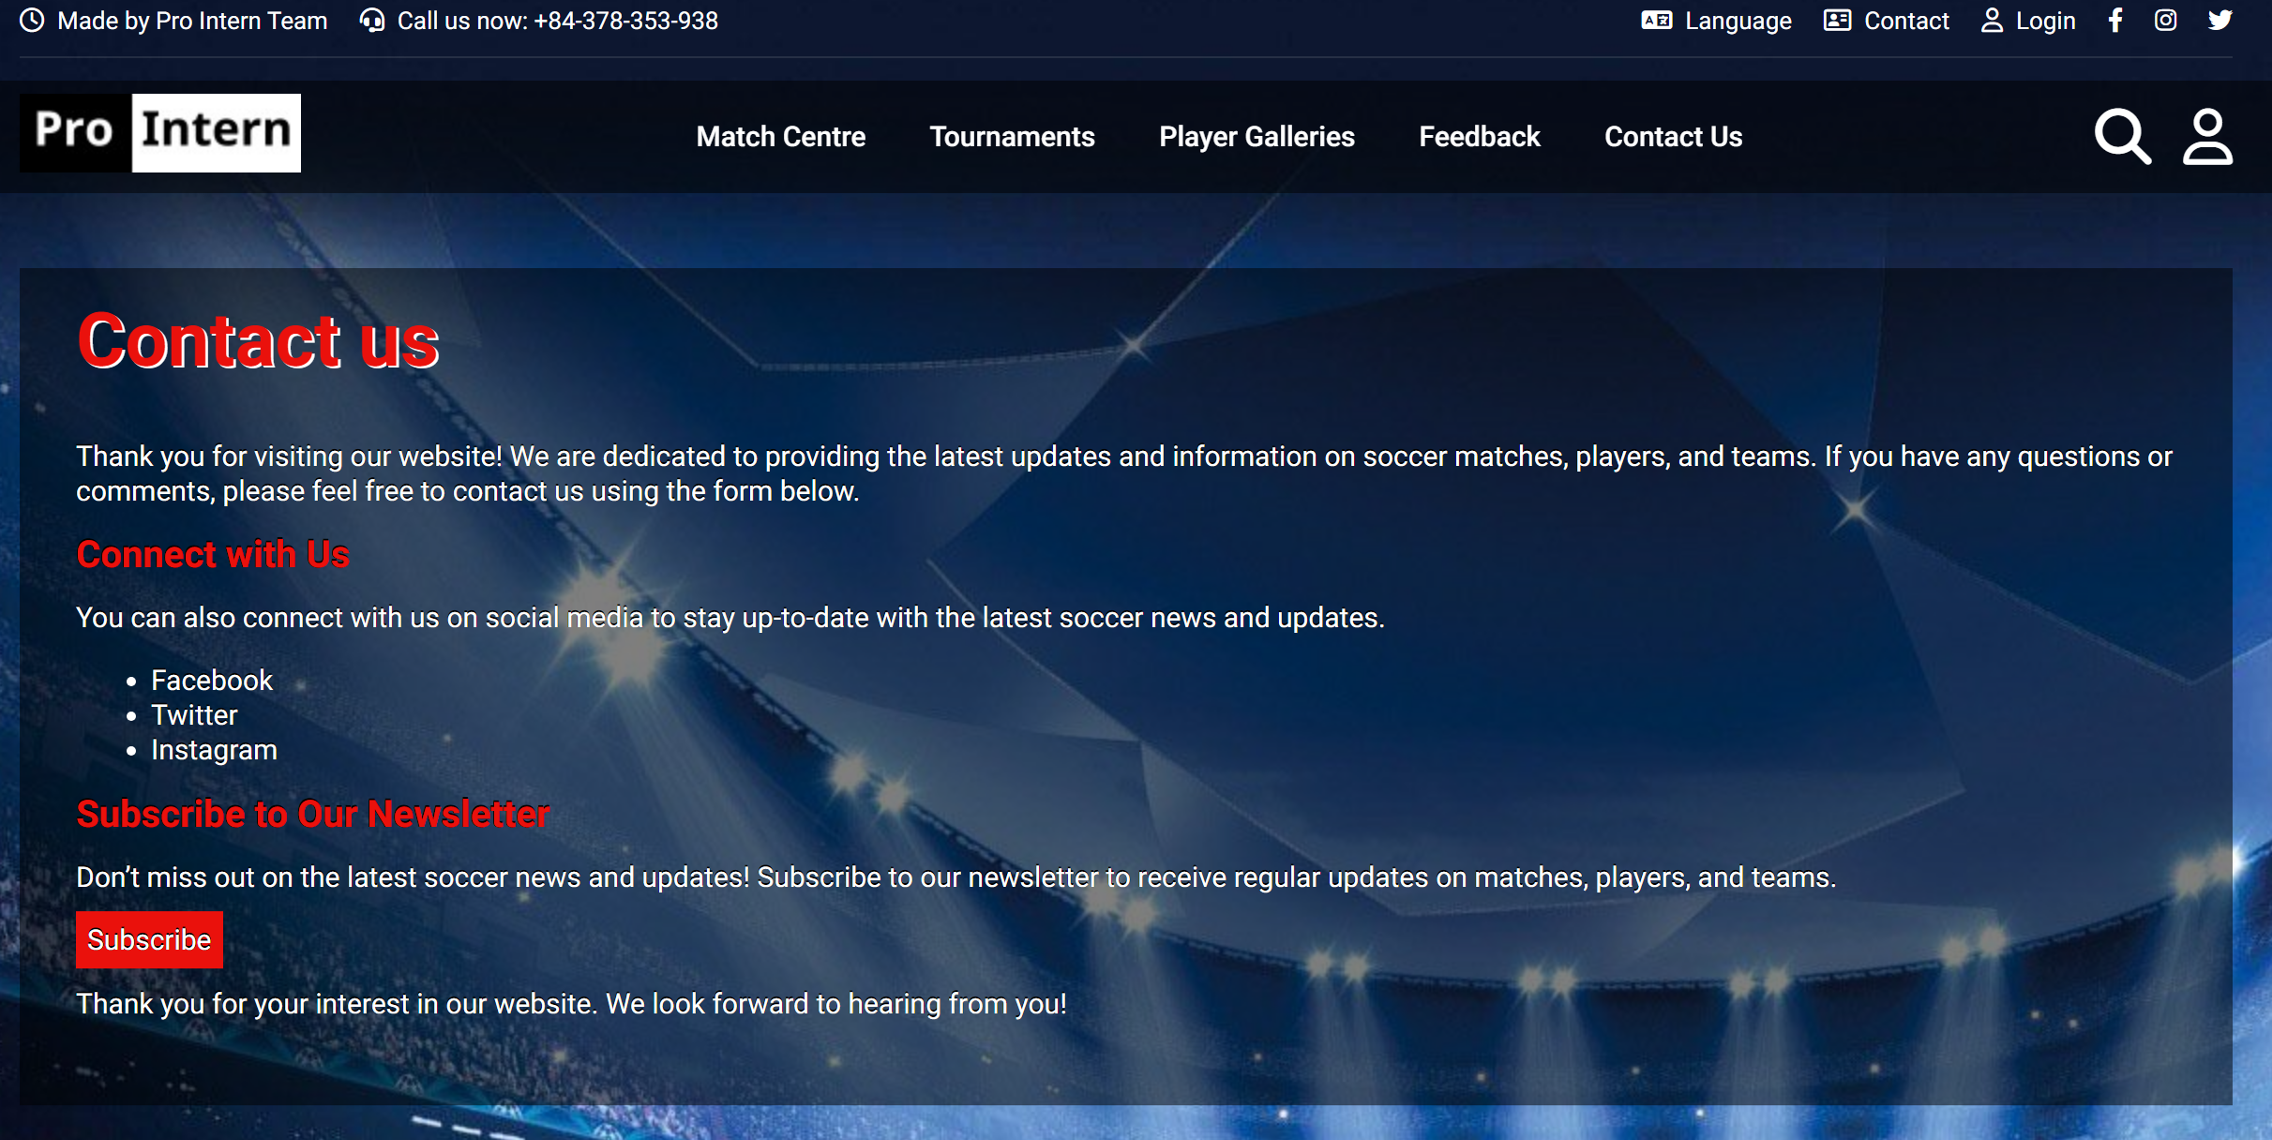

Footer

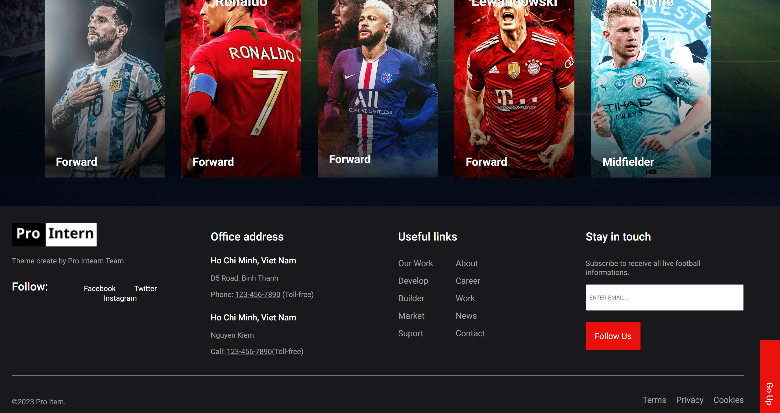

**Responsive for mobile device**

**Width : 1024px**

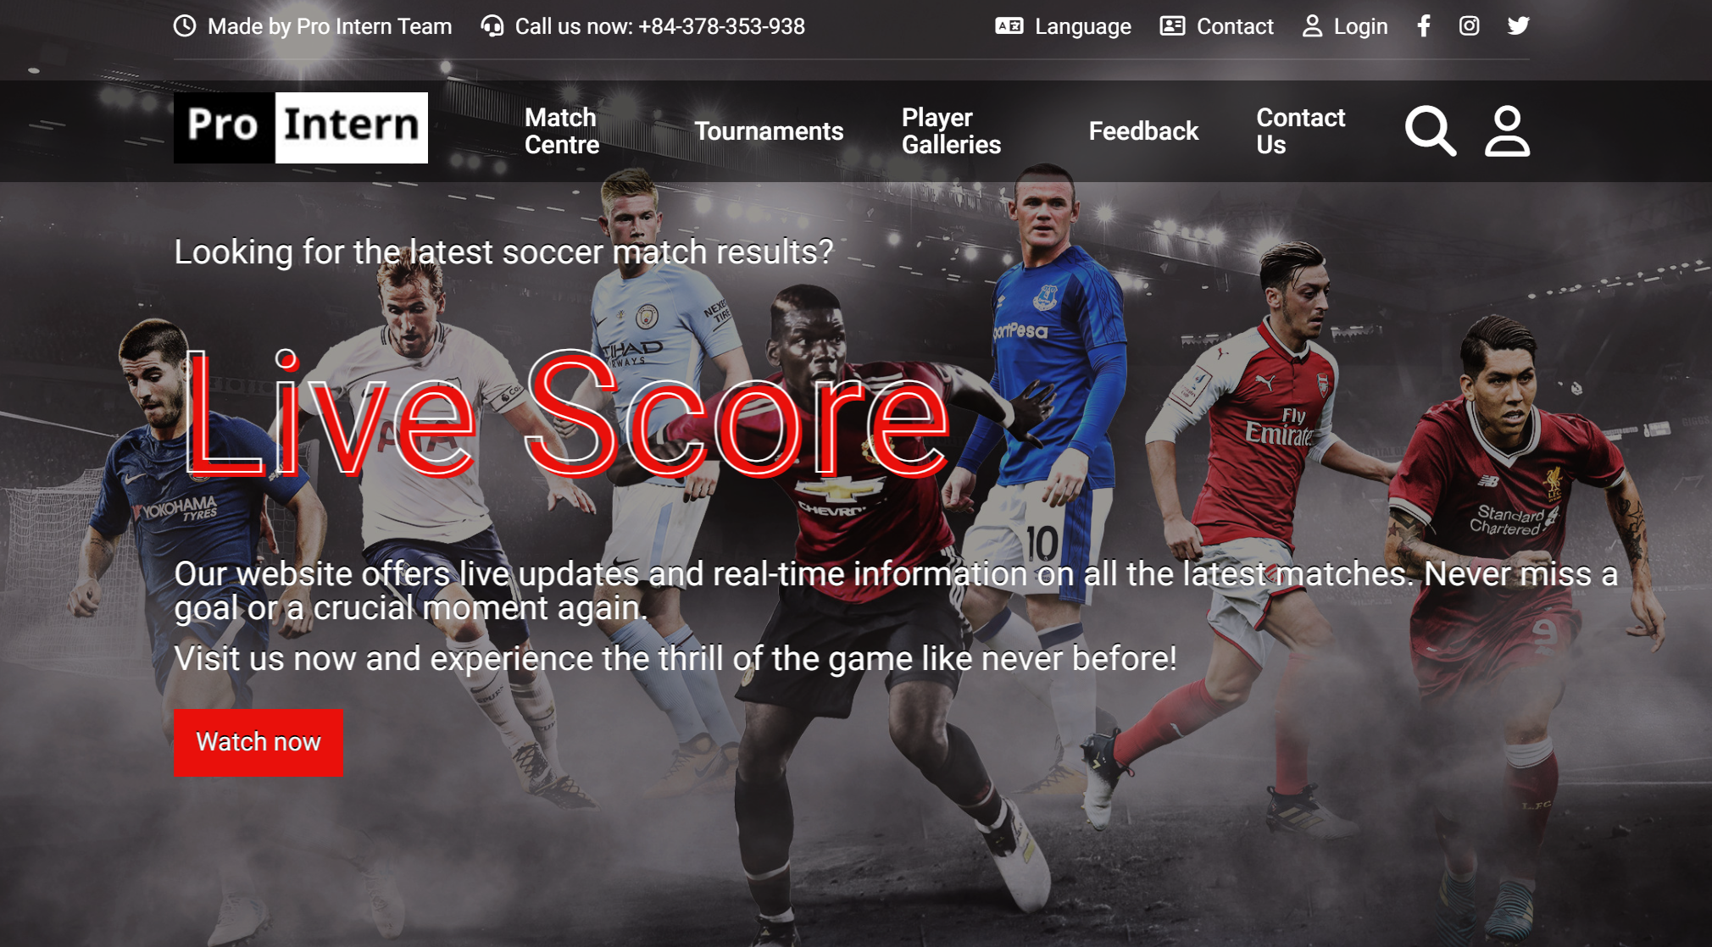

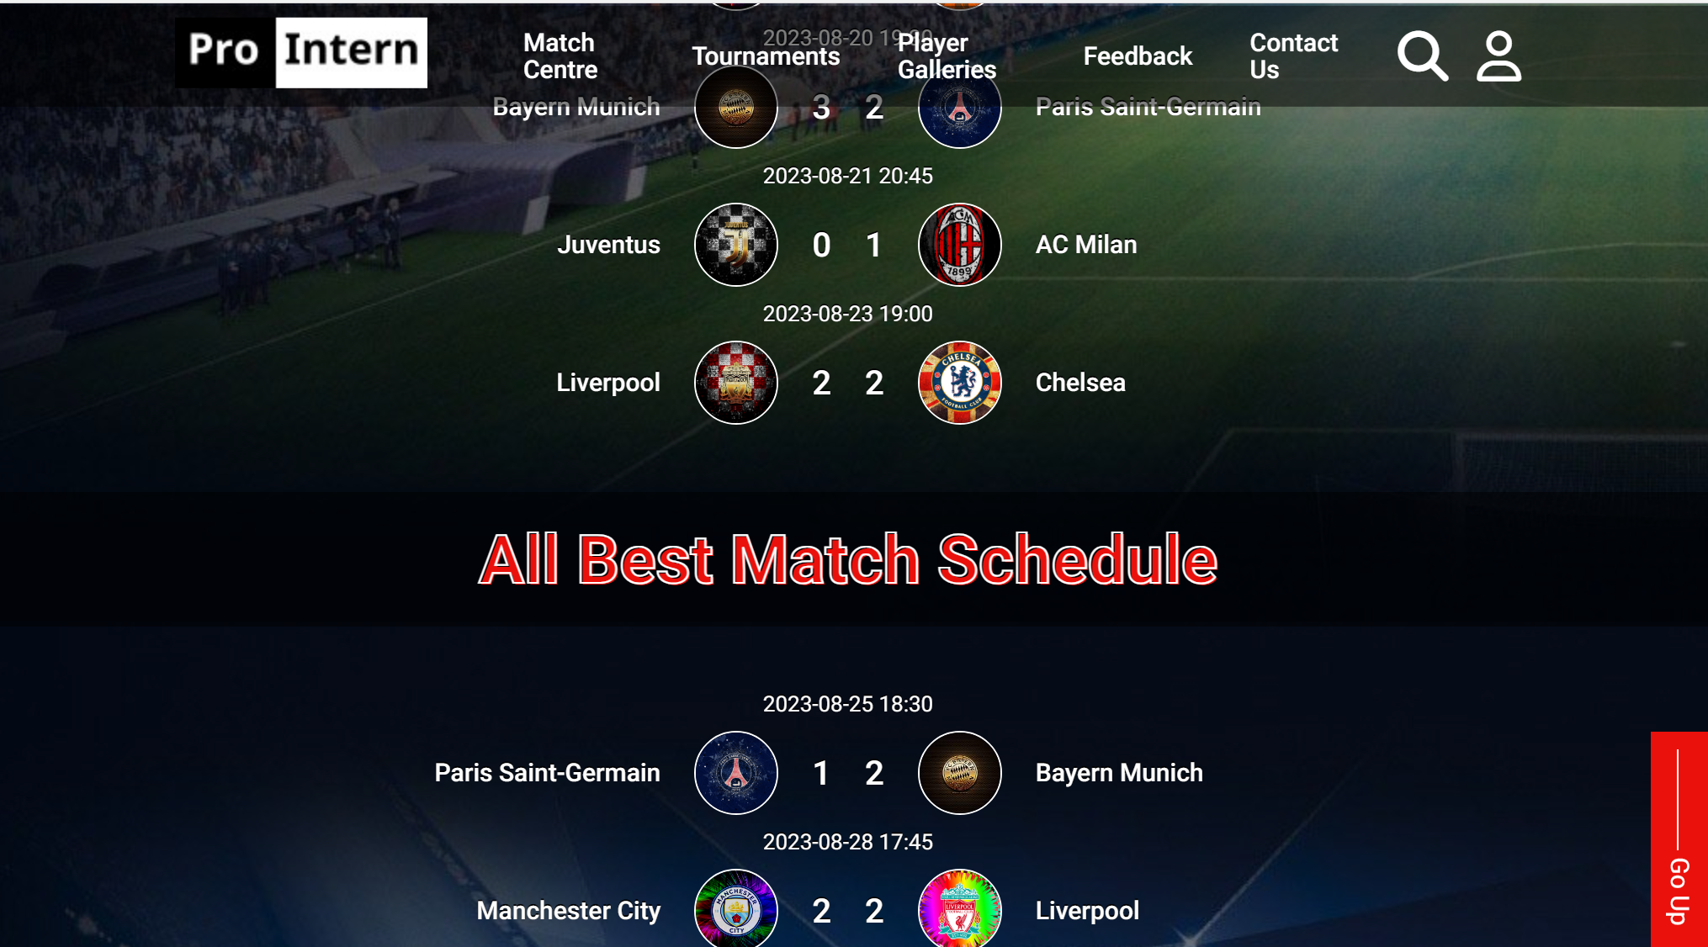

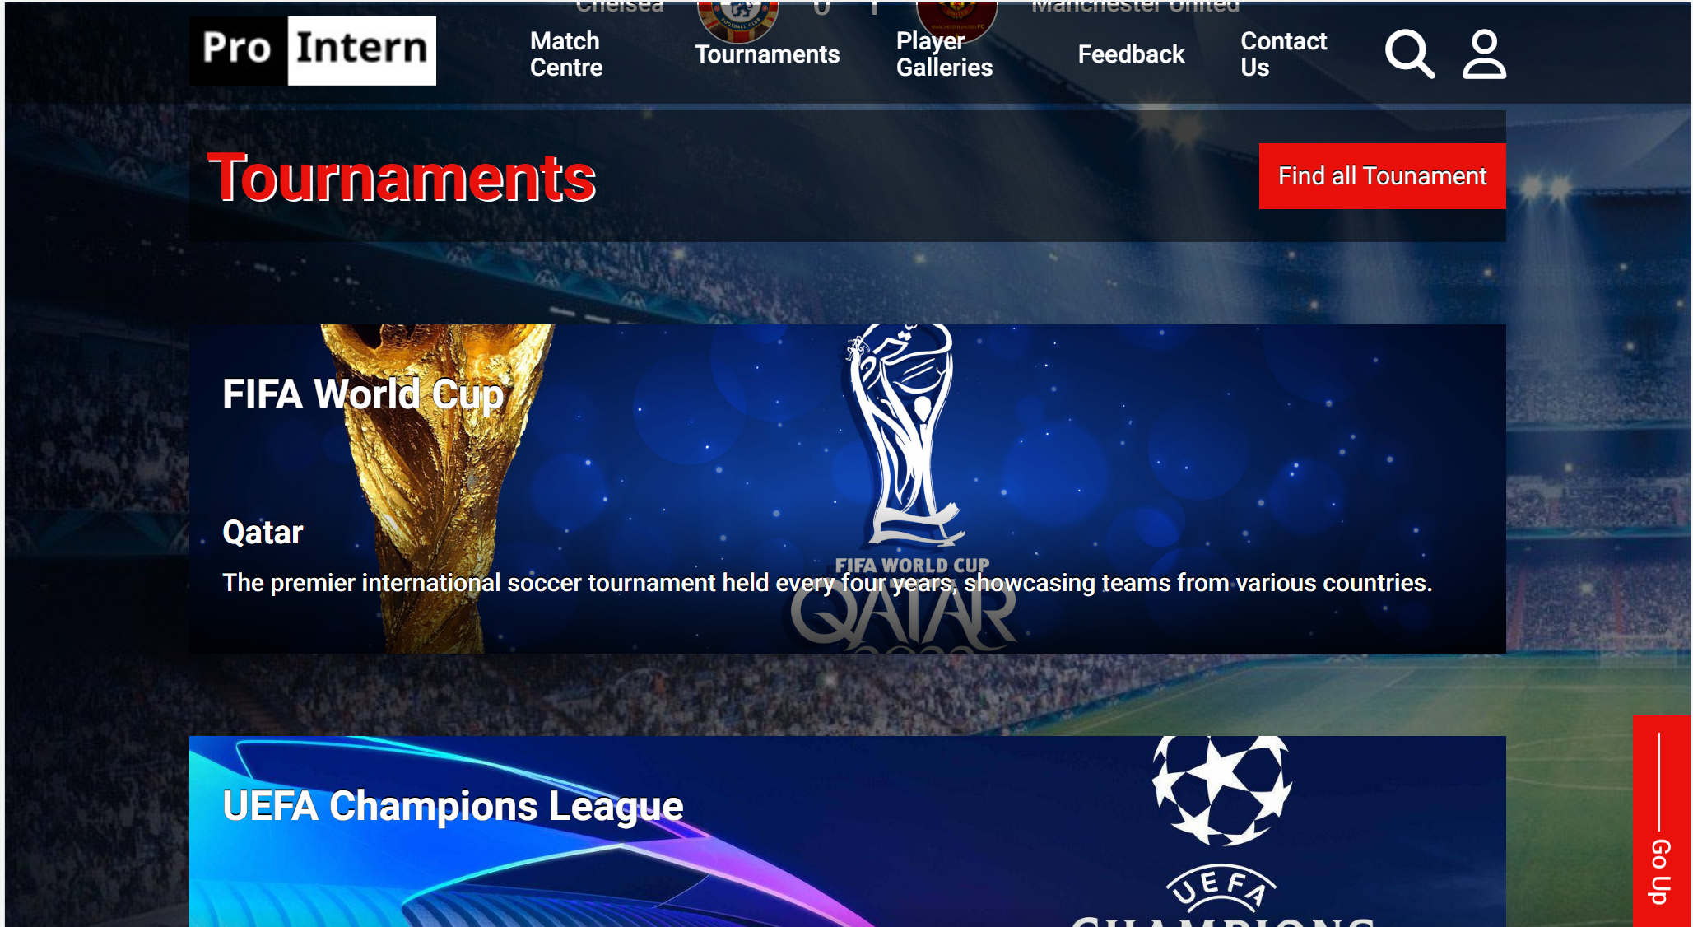

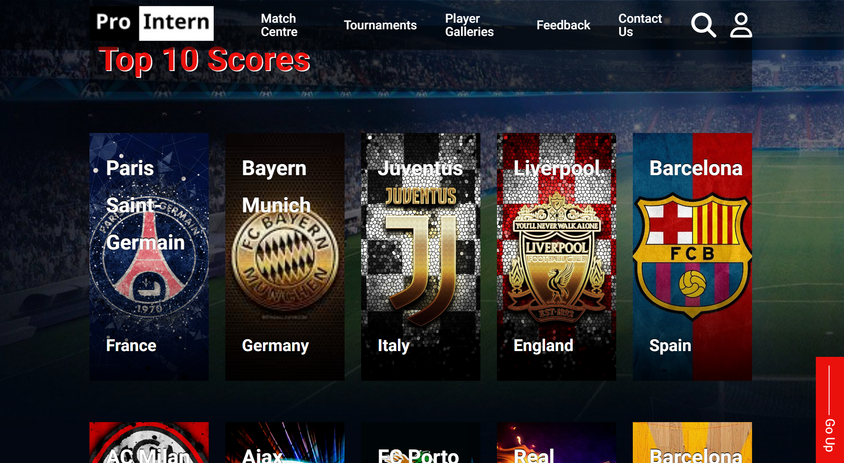

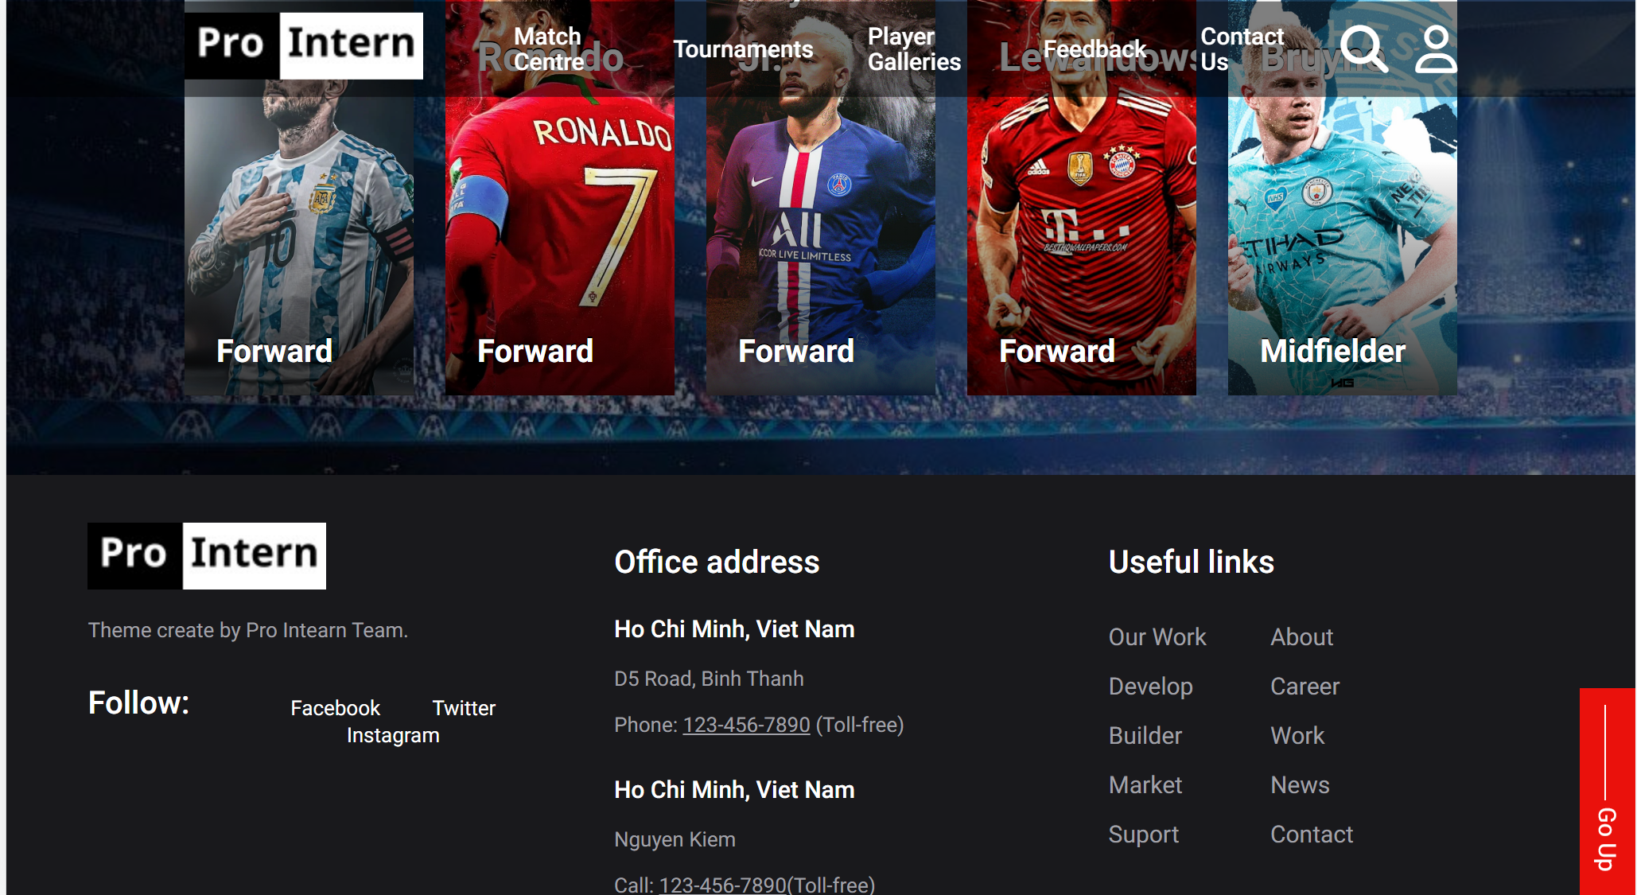

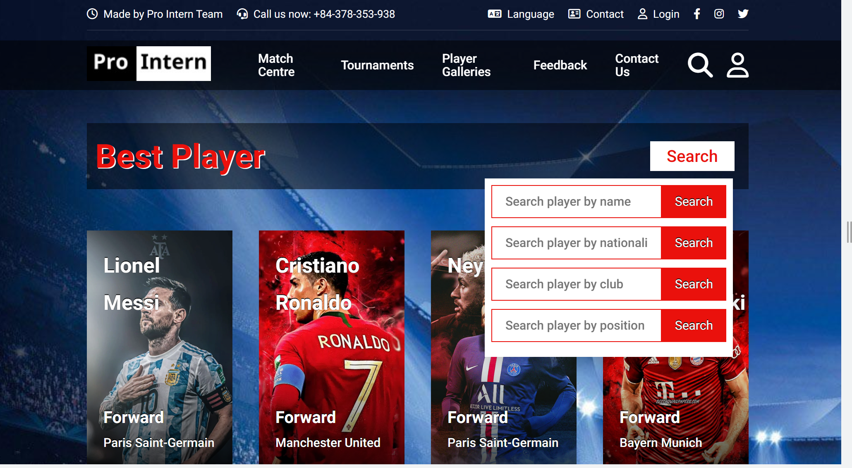

**Width 800px**

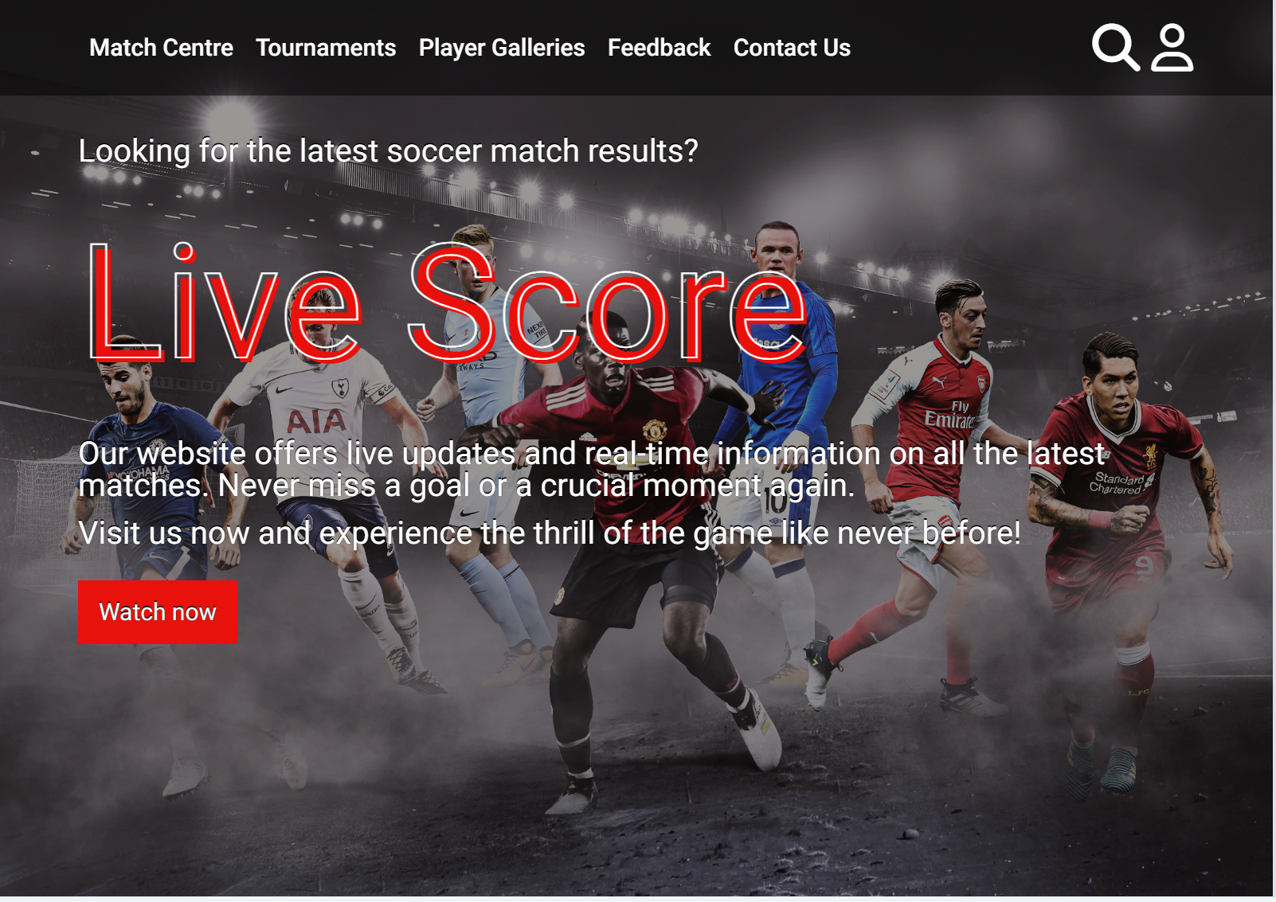

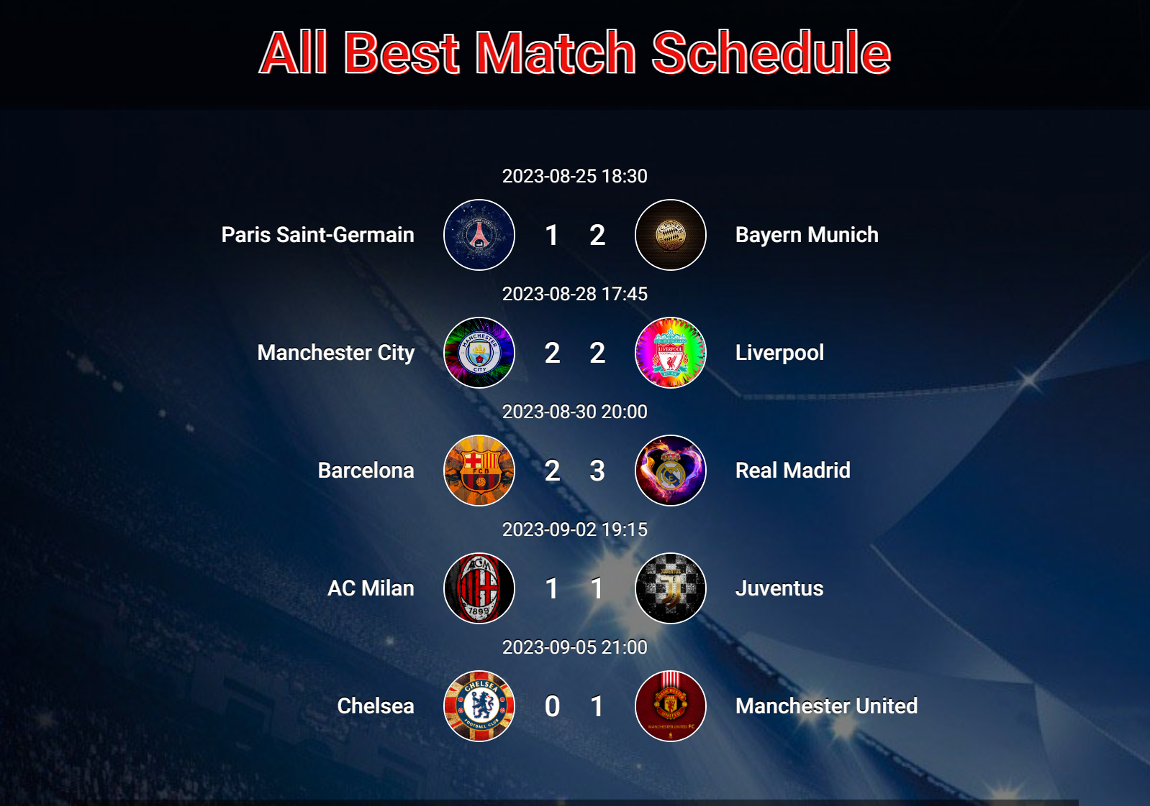

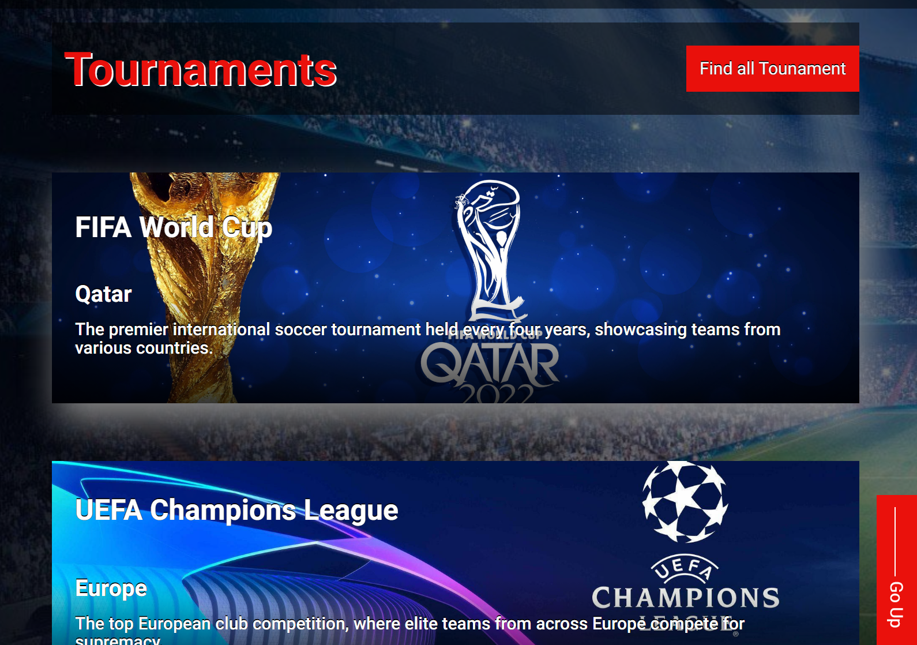

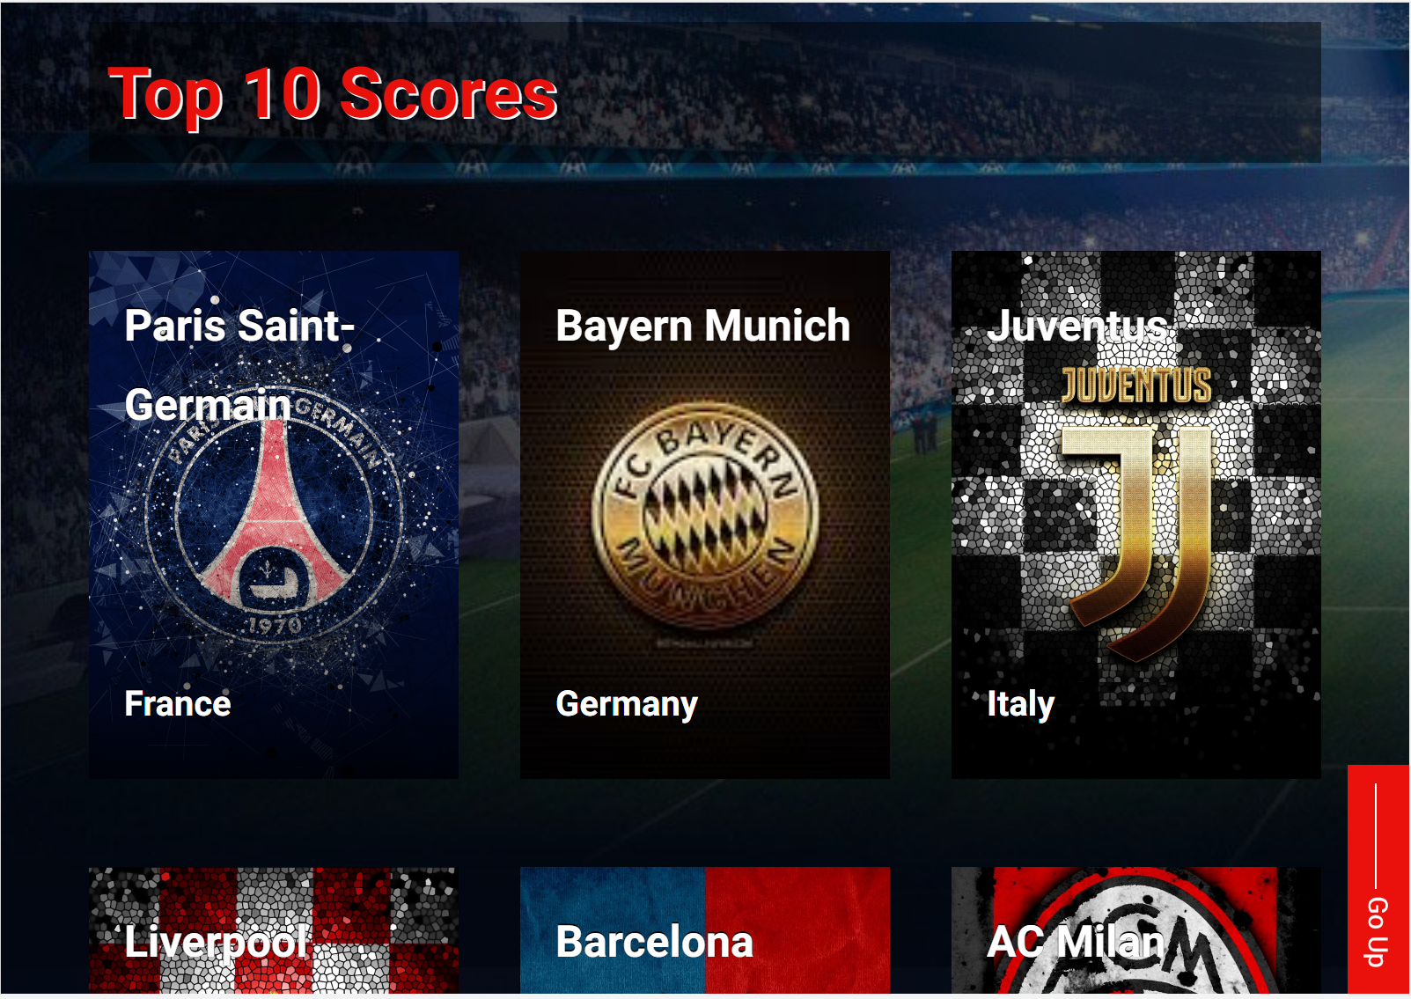

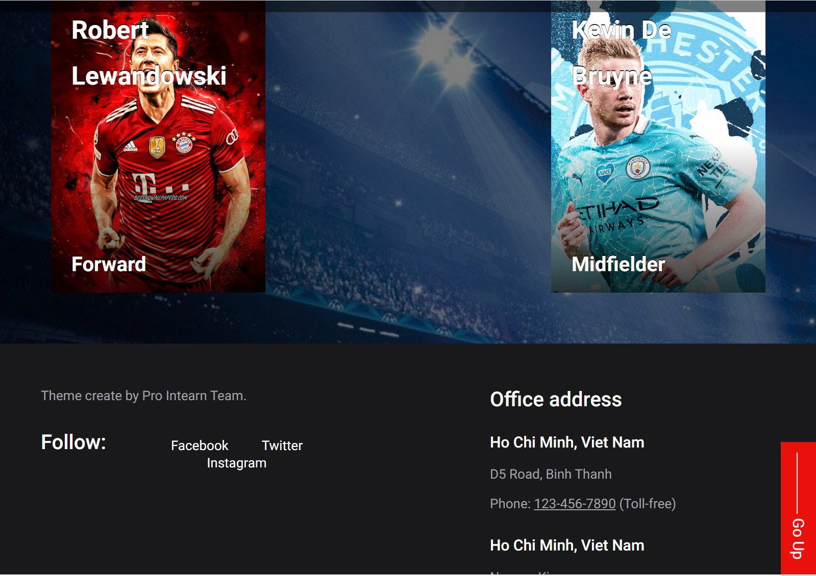

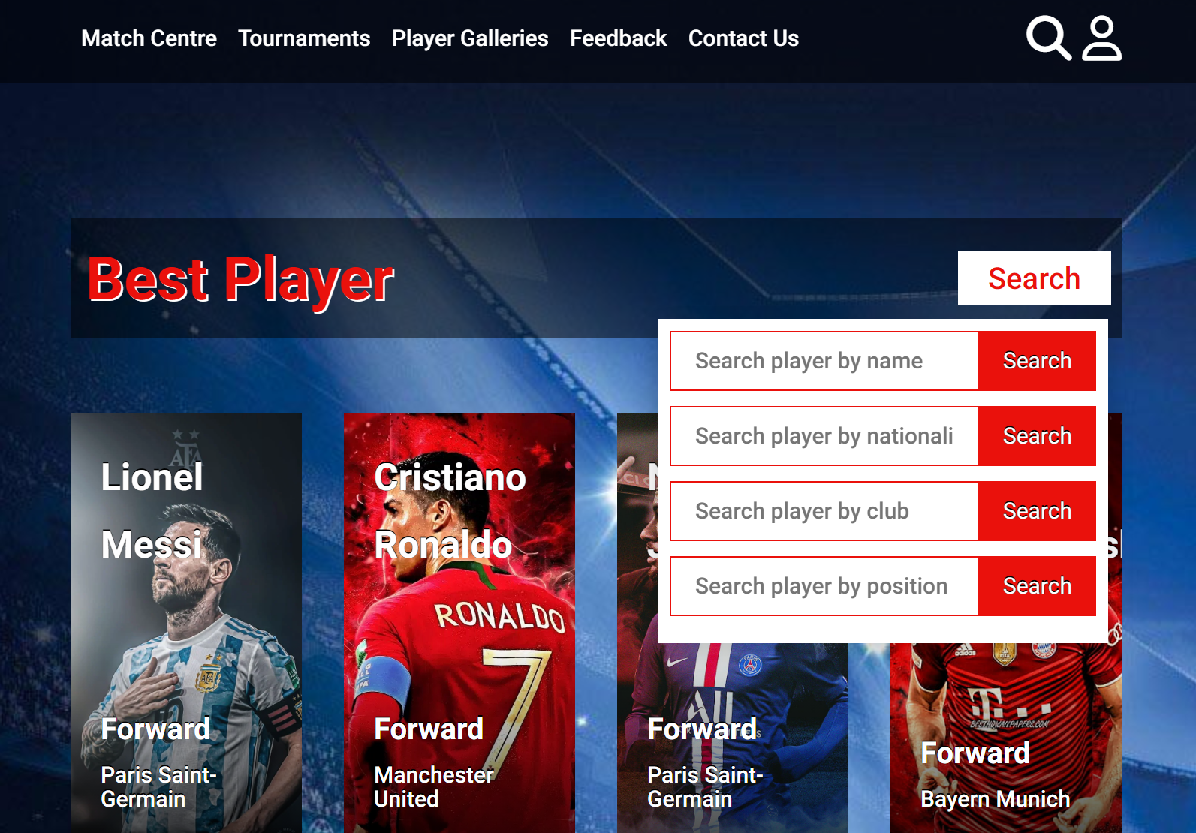

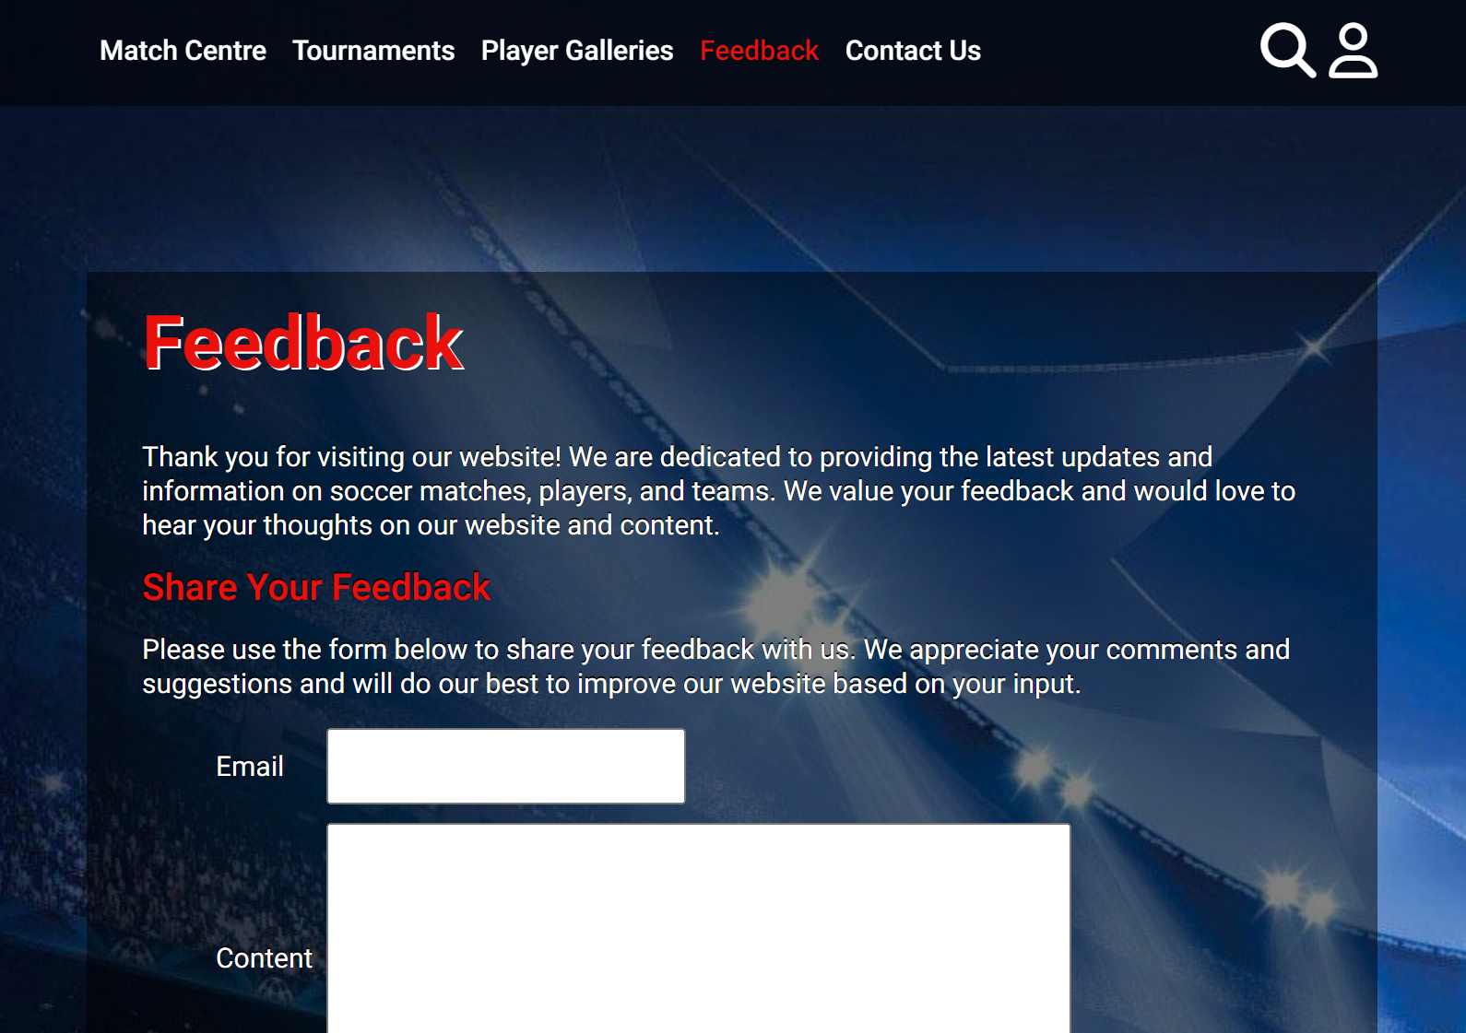



**Width 600px**

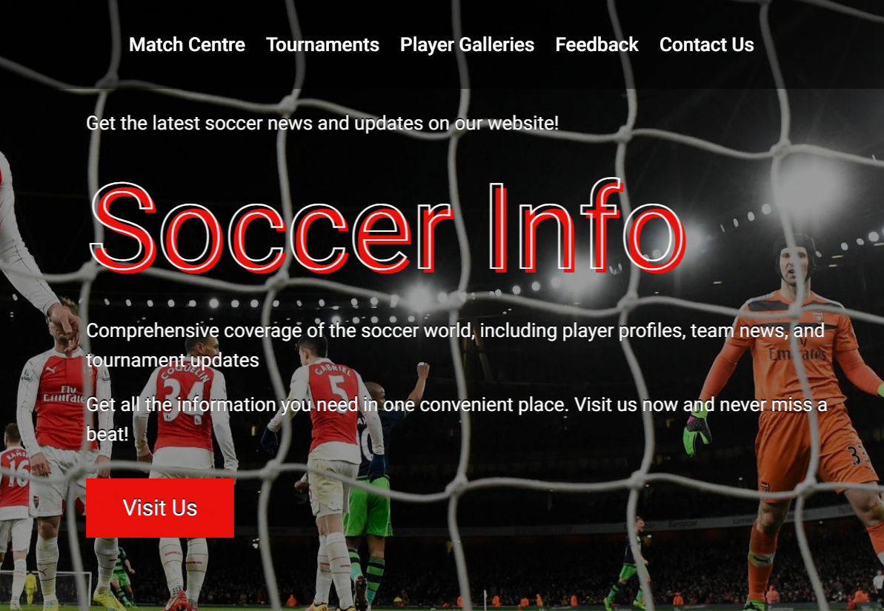

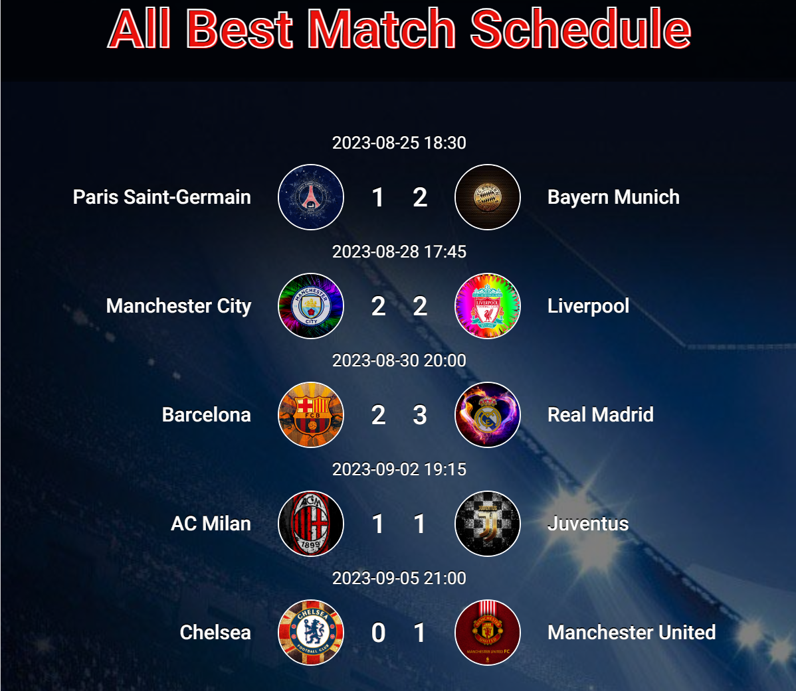

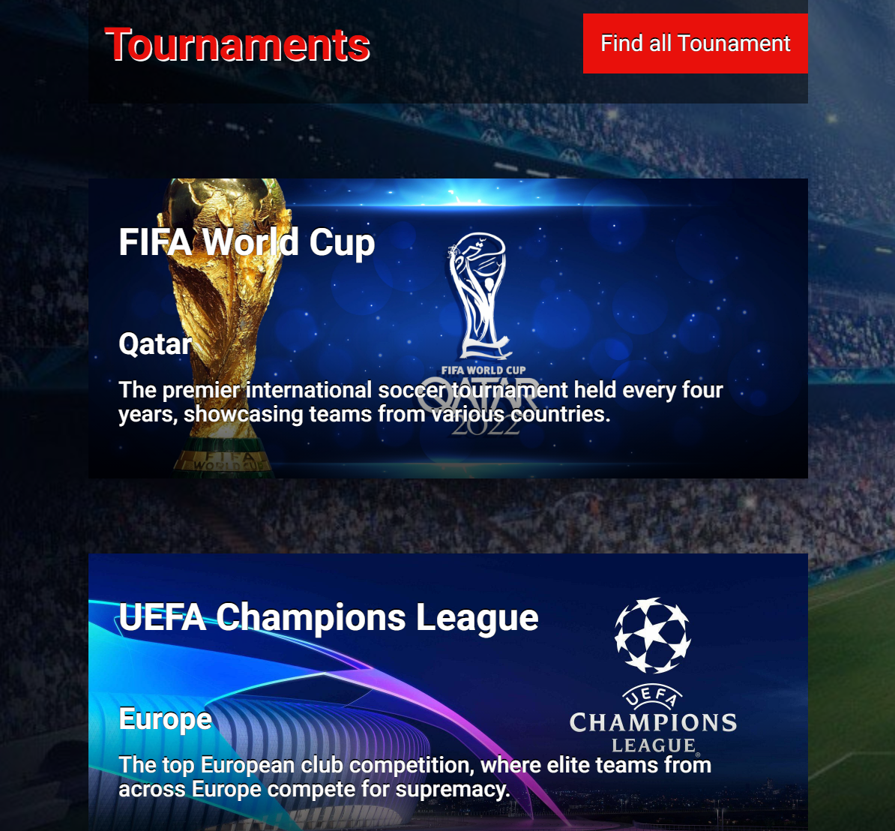

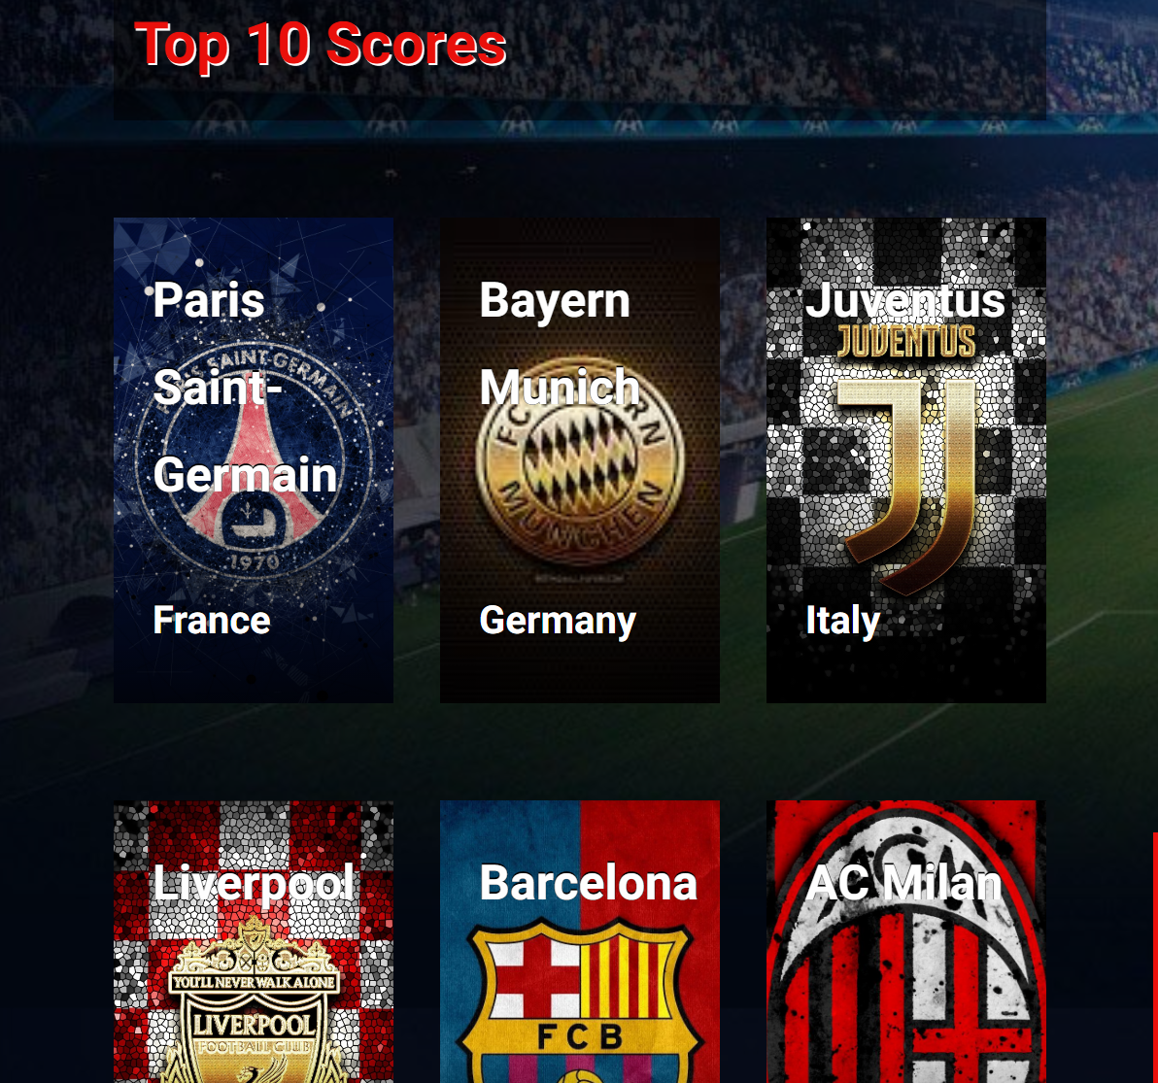

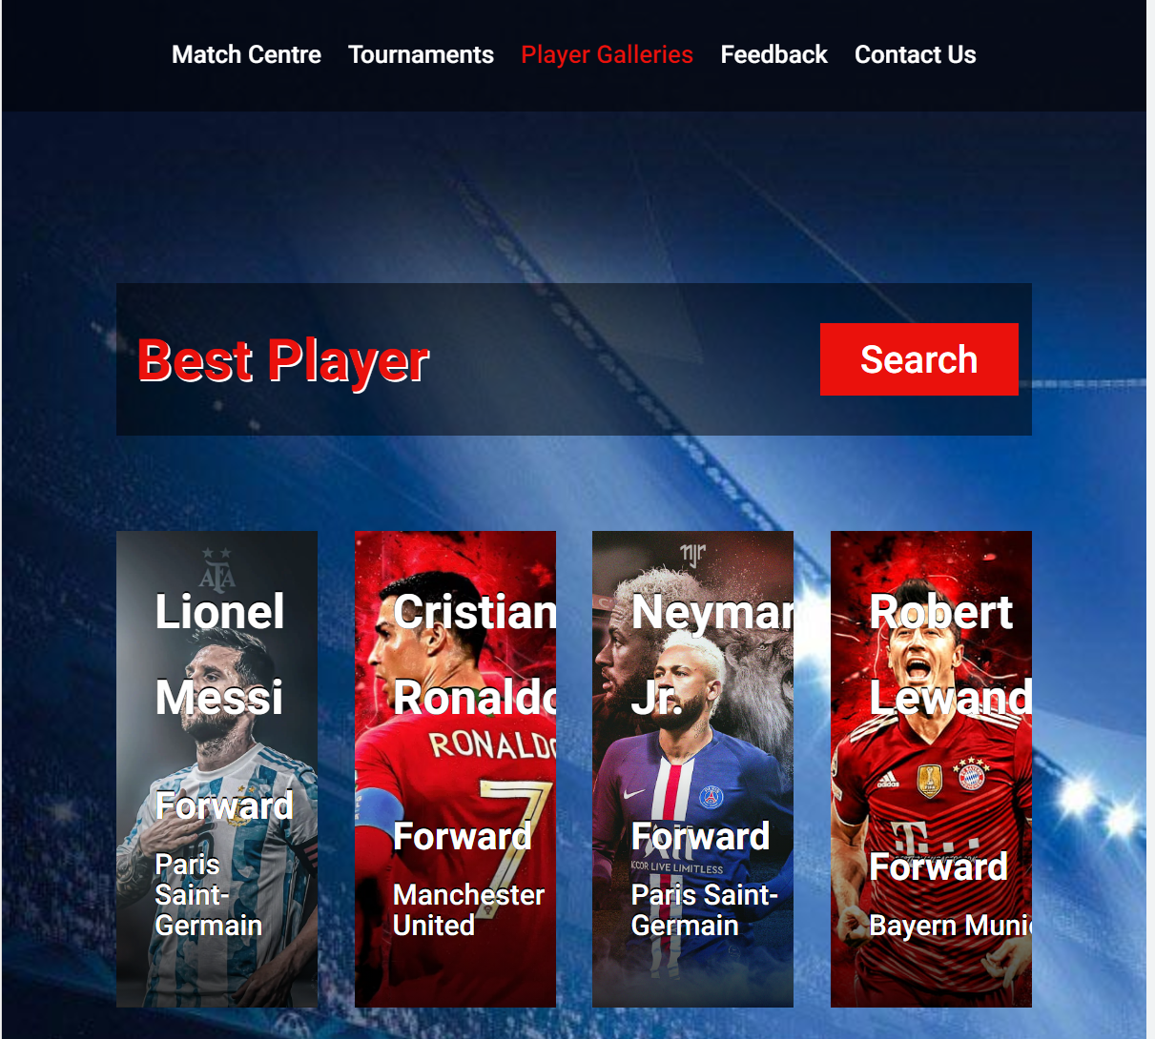

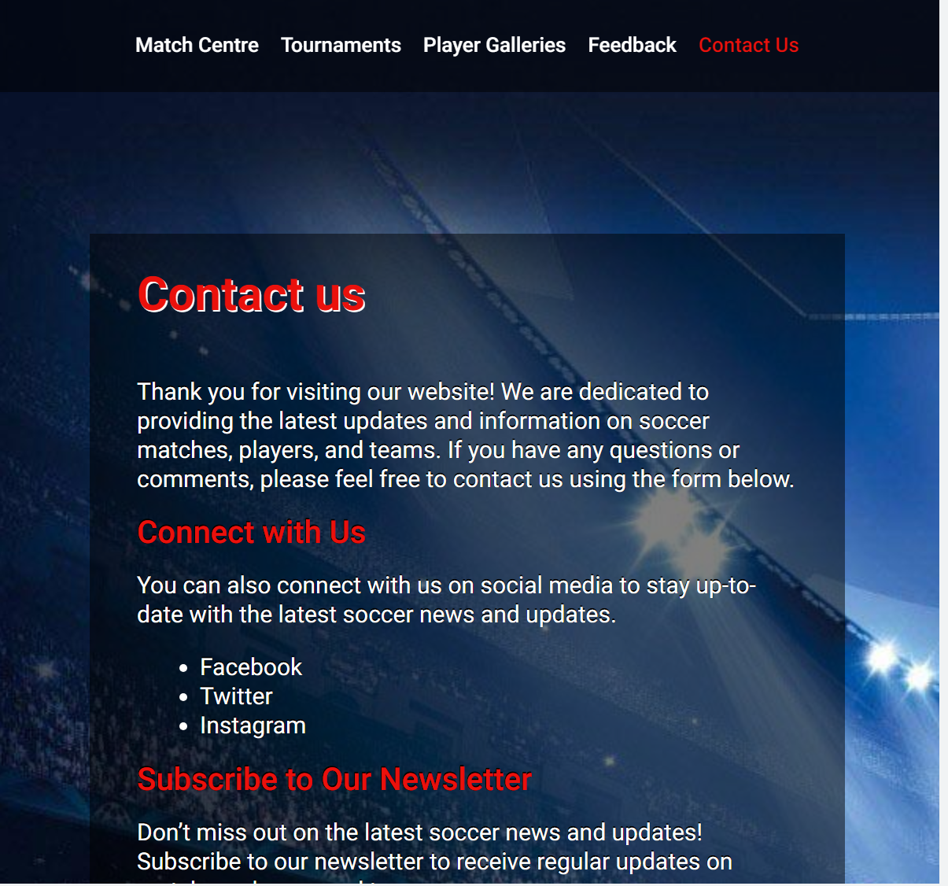

**Width 480px**

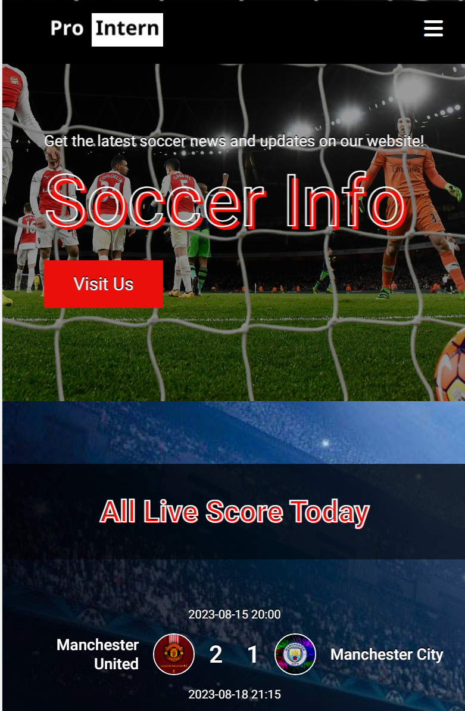

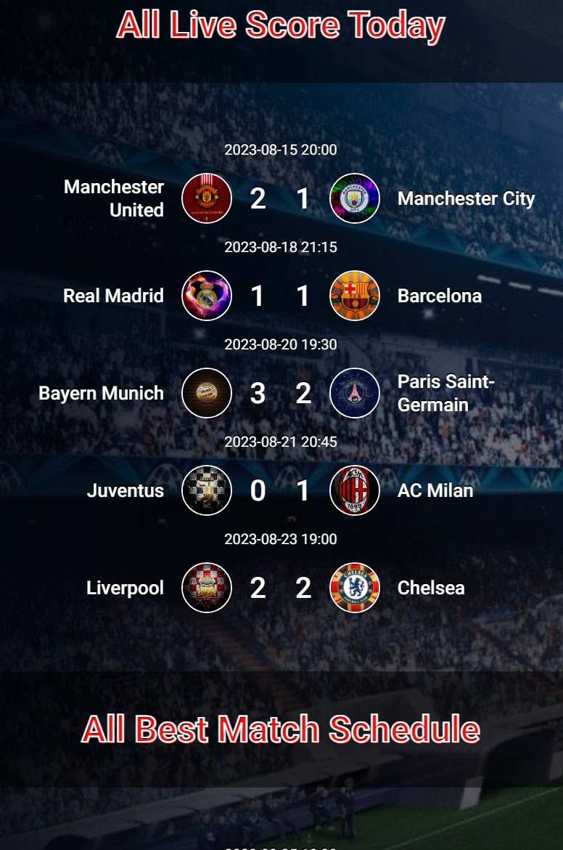

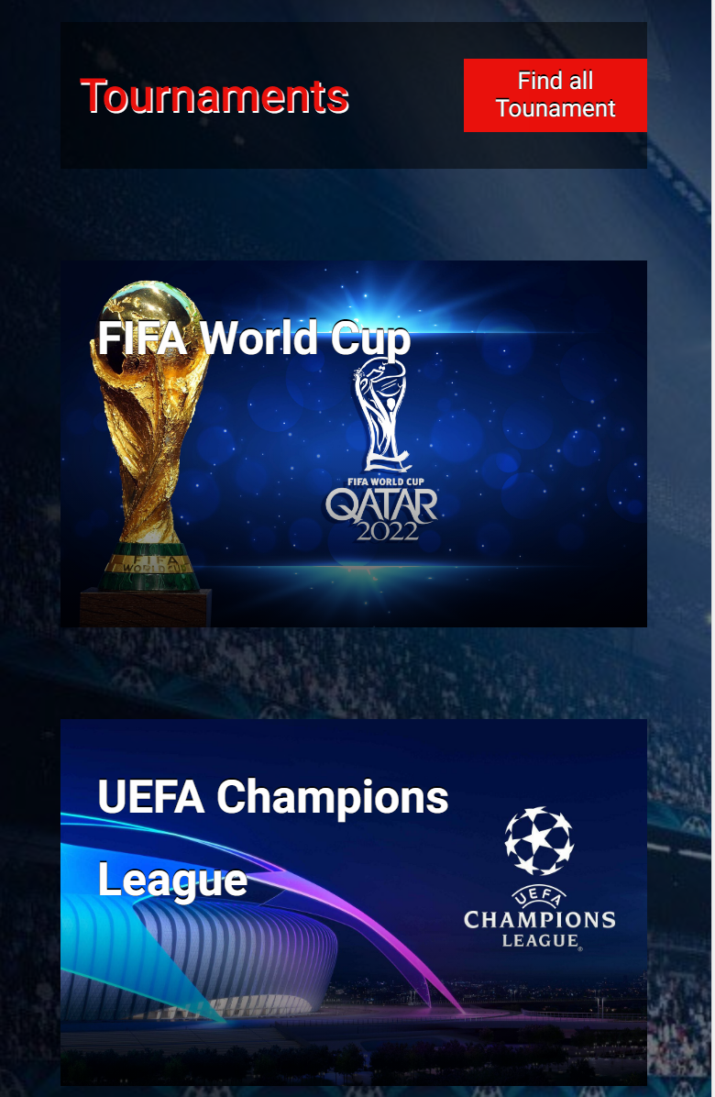

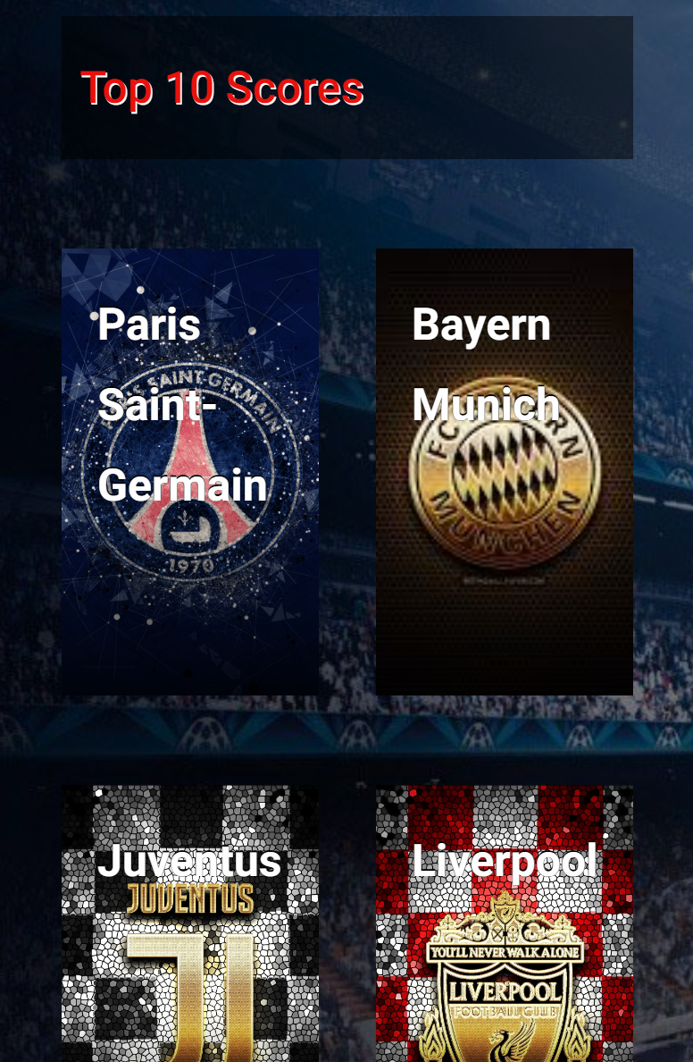

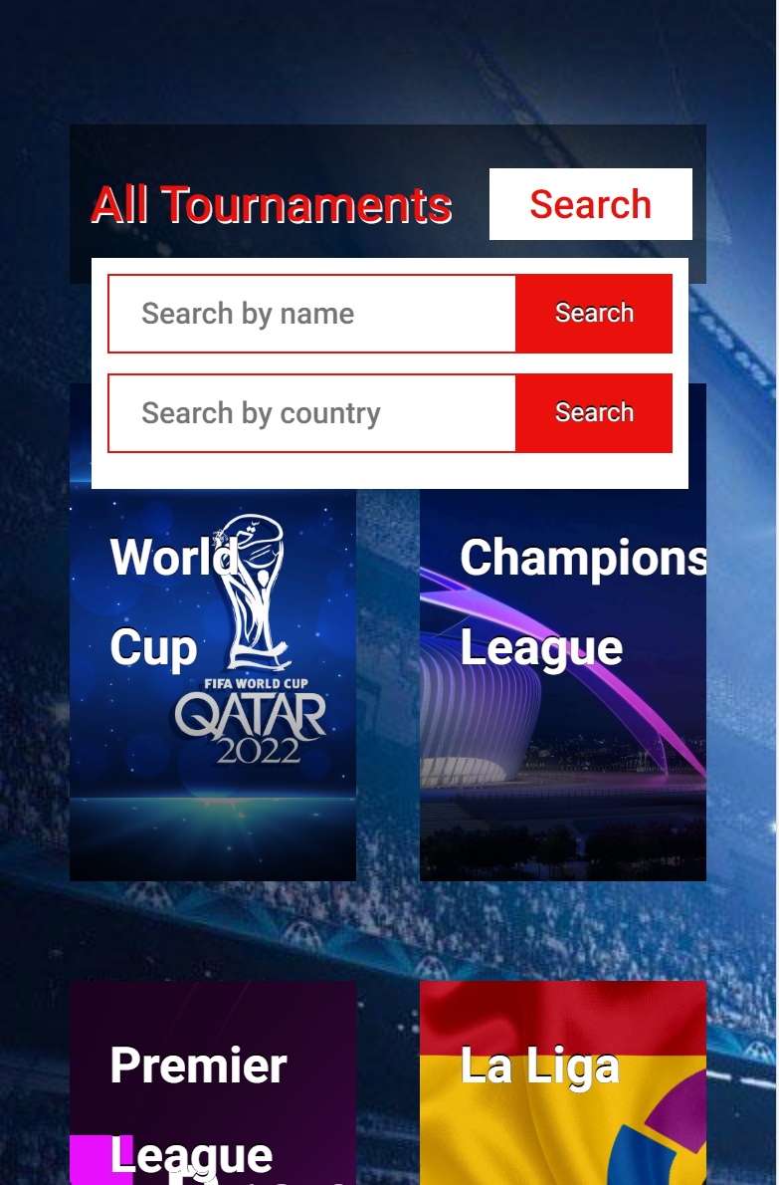

**7. Work Timeline:**

Planning and Interface Design via sketches: 2h

Interface creation, styling, data manipulation, integration into the interface, implementation of logic for filters, searches, etc.: 60h

Testing, bug fixing, and presentation preparation: 10h

**8. Responsibilities of Each Member:**

Design Team (Creating an appealing and interactive interface):

Mr. Tran Thanh Dat

Mr. Tran Bao Huy

Mr. Nguyen Ngọc Hải

Mr. Pham Hong Nghia

Development Team (Building features and data integration):

Mr. Tran Thanh Dat

Mr. Nguyen Ngoc Hai

Testing Team (Website testing, bug identification, and ensuring stability):

Mr. Tran Bao Huy

Mr. Pham Hong Nghia

**9. Conclusion:**

We firmly believe that the Soccer League project will bring football enthusiasts an engaging and valuable experience. Sharing information, tracking schedules, and updating results will become easier than ever before, thanks to the combined efforts of the development team and the support from the community.

We hope that this project will contribute to enriching your passion for football. With only 72 hours for execution, there are numerous ideas that we planned but couldn't implement. We look forward to receiving feedback and suggestions to provide us with the opportunity to refine and further develop this project.

Sincere gratitude and looking forward to seeing you on the Soccer League website!

Best regards,

Pro Intern Team